REPUBLIC OF THE MARSHALL ISLANDS

MARSHALL ISLANDS MARITIME INVESTMENT PROJECT



***HOW TO GET INFORMATION OR RAISE A CONCERN ABOUT THE MARSHALL ISLANDS MARITIME INVESTMENT PROJECT***

**Grievance Redress Mechanism**

**UPDATED: February 2024 (Version G)**

Prepared by

DIDA, RMI Ministry of Finance

**Quality Information**

|  |  |
| --- | --- |
| **Document** | MIMIP Grievance Redress Mechanism |
| **Date** | 05 January 2023 |
| **Prepared by** | CIU Safeguards Team |
| **Reviewed** | CIU/MIMIP |

**Revision History**

|  |  |  |  |
| --- | --- | --- | --- |
| **Revision** | **Revision Date** | **Details** | **Revision By** |
| A | January 2019 | Final Version from ESMF | ESIA/DIDA |
| B | 10 July 2020 | Update for operationalization | DIDA |
| C | 30 July 2020 | Incorporate WB team feedback | WB/DIDA |
| D | 03 November 2020 | Updated for operationalization and Final WB comments incorporated | DIDA/CIU |
| E | 06 June 2021 | Updated to include GBV, SEAH, VAC, HT pathway and contact details | DIDA/CIU |
| F | 05 January 2023 | Updated to reflect change in DCP and IA for Component 2.4 (e) and include new GRM Register Form | DIDA/CIU |
| G2 | 02 February 2024 | Updated to reflect change of personnel | DIDA/CIU |

Revision G2

**Contents**

List of Acronyms 3

1. Introduction 4

2. Purpose of the MIMIP GRM 5

3. How the MIMIP GRM Operates 5

4. Gender-Based Violence, Sexual Exploitation, Abuse or Harassment 8

Violence against Children and Human Trafficking 8

5. How to Make a Compliant 10

6. GRM Information Handling and Storage 11

7. Communicating the GRM with Stakeholders 11

8. Reporting and Learning 11

Form A: MIMIP Grievance Register Form 13

Form B: MIMIP Grievance Register Form for GBV, SEAH, VAC and HT Complaints 15

Form C: Communicate GBV or HT Allegation to MIMIP Project Manager 16

Form D: Survivor Consent Form 17

Form E: World Bank & RMI Government: Project Grievance Register 18

**Contact Information**

**Marshall Islands Maritime Investment Project**

In person: Carl Hacker or Celine Aliven

RMIPA Building, Level 2, Delap, Majuro 96960

By phone: (692) 625-8269 or (692) 456-2958

By email: [kadacsh@gmail.com](mailto:kadacsh@gmail.com)

By mail: RMIPA, P.O. Box 109, Amata Kabua Blvd.

Marshall Islands 96960

Internet: https://www.ciudidasafeguards.com/grm

# List of Acronyms

AP Aggrieved Party

CIU Central Implementation Unit

CSS Construction Site Supervisor

DCP Designated Contact Person

DIDA Division of International Development Assistance (Ministry of Finance)

GBV Gender-based violence

GM General Manager

GRM Grievance Redress Mechanism

HT Human trafficking

IA Implementing Agency

ISPS International Ship and Port Facility Security

MIMIP Marshall Islands Maritime Investment Project

MoF Ministry of Finance

NDMO National Disaster Management Office

PM Project Manager

RMI Republic of Marshall Islands

RMIPA Republic of Marshall Islands Port Authority

SEAH Sexual exploitation, abuse and harassment

TA Technical assistance

WAM Waan Aelon in Majel.

VAC Violence against children

WB World Bank

WUTMI-WIM WUTMI *Weto in Mour*: Violence against Women and Girls Support Service

# Introduction

This document is relevant to anyone who has an interest in the Marshall Islands Maritime Investment Project (MIMIP). This includes members of the public who would like information about the project, as well as people who wish to express concerns or make complaints about the project.

The purpose of the MIMIP is to improve sea transportation services in the Marshall Islands so that it is more efficient, reliable, and affordable which will lead to economic and social benefits. As shown in *Figure 1*, the Project has three main components and includes a series of activities aimed at improving maritime infrastructure (docks) and services for better safety and security. The MIMIP will undertake work in various locations throughout the RMI including Arno, Ebeye, Jaluit, Majuro (Delap and Uliga) and Wotje. The Project will also be conducting research and carrying out activities to address environmental and social factors associated with maritime investment and strengthening the capacity of port governance and management.

The MIMIP is being funded by the World Bank and the RMI government and the implementing agencies include the Marshall Islands Port Authority, the Ministry of Finance, the Ministry of Justice and the National Disaster Management Office. The MIMIP is being implemented over a five-year period, 2019 - 2024.

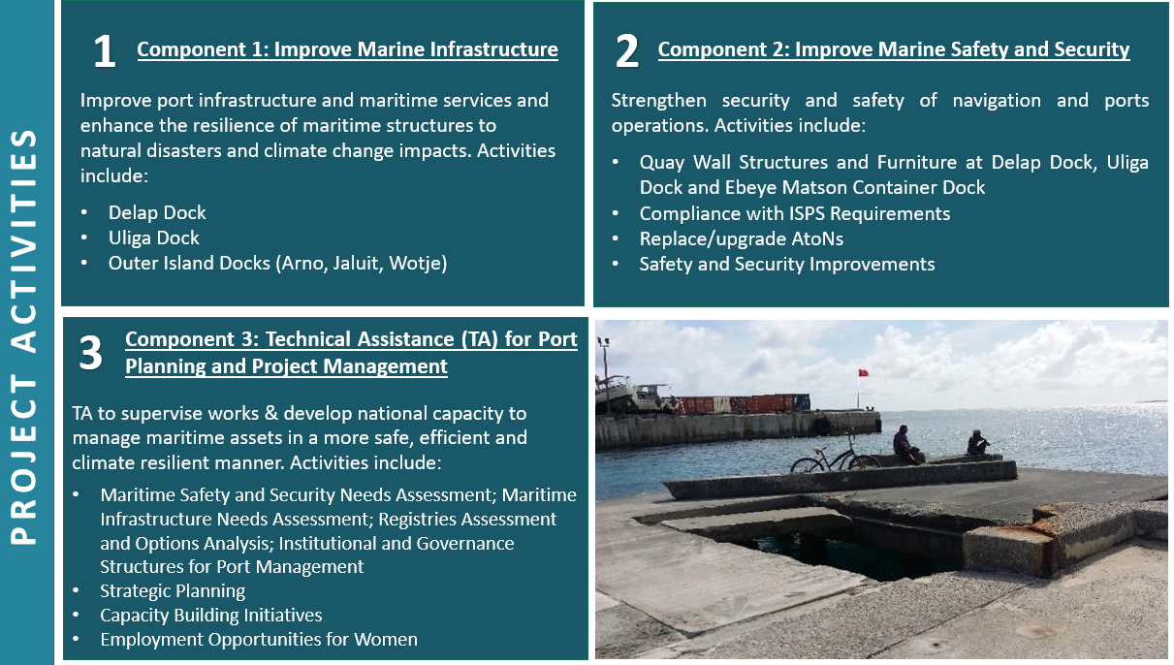**Overview of MIMIP Project Components and Activities**

If you would like more information about the MIMIP, please do not hesitate to contact any member of the Project team or any staff from the Division of International Development Assistance (DIDA), Ministry of Finance. We also welcome suggestions about how to improve the Project, including communication with the public, so please feel free to contact the Project Team if you have ideas. Project contract information is provided on page 11.

# Purpose of the MIMIP GRM

In addition to requesting information, making suggestions, raising a concern and making a compliant (also called a grievance) can be raised about any aspect of the MIMIP, including project activities, services, environmental or social impacts, safety issues and about the behavior or attitudes of people carrying out project works. This includes issues related to physical or sexual harassment, abuse, or violence.

The MIMIP strives to prevent any concerns from arising by using clear communication, proper safety procedures, providing staff training, and ensuring that all project personnel and contractors adhere to a strict “Code of Conduct”. However, we recognize that there may still be times when issues arise and therefore, it is essential that all members of the public can raise concerns or make a complaint.

The process of making a complaint and ensuring that it is fully investigated and addressed is called a Grievance Redress Mechanism (or GRM).

The purpose of the MIMIP GRM is to ensure that:

* the basic rights and interests of everyone affected by the Project are protected,
* any concerns about the Project during predesign, design, construction and post construction phases are addressed in a fair, timely and effective manner,
* all complaints about the behavior or attitude about Project staff, consultants, contractors and implementing agencies is fully investigated and addressed, and
* the Project adjusts and improves in response to people’s concerns and feedback aimed at preventing any further issues.

This document explains the process that will be used to investigate and resolve any concerns that are raised as quickly and respectfully as possible.

The MIMIP recognizes that there are different kinds of issues that may arise so it provides two different pathways: one for general issues and one for “serious or sensitive” matters that may require the involvement of external agencies such as the police and/or counseling services.

If you are concerned, or you know someone who is concerned, about any aspect of the MIMIP, please contact the Project Director or anyone else working on the project as soon as possible.

# How the MIMIP GRM Operates

The MIMIP GRM covers the entire duration of the project because questions, concerns or complaints can arise at any time, including design, implementation and construction and post-construction phases.

**Key Points**

* The MIMIP GRM only deals with project related matters.
* The MIMIP GRM can be used by an individual or by a group of people who have concerns about how the project is impacting their lives.
* Grievances can be raised in an open and public manner, or anonymously and in confidence.
* It provides different options for lodging a complaint (see page 7). This means that people can raise their concerns with someone they are not personally connected with and can also choose to talk with either a man or a woman.
* The identity of people who make a complaint will be kept confidential and all documentation related to the complaint will be kept in a secure location that can only be accessed by the Project Manager.
* There are different kinds of issues that could arise during project implementation which require different kinds of responses such as “series or sensitive” matters including situations that involve gender-based violence (GBV), sexual exploitation, abuse, or harassment (SEAH) as outlined in Section 4.
* There is a person in charge of making sure that the MIMIP GRM process operates properly, and that person is called the “Designated Contact Person” or the “DCP”,
* TheProject Director for MIMIP is the DCP for all grievancesand will stay involved until the matter is resolved and will be the main point of contact for the person making the complaint. Note: during the construction period, the Construction Site Supervisor (CSS) can serve as the DCP until the matter is resolved.
* If concerned persons are unsure who to contact, they can seek information or raise grievances with any staff involved in project implementation who will immediately direct the matter to the appropriate party for resolution.
* The intent of the GRM is to solve problems as quickly and fairly as possible. This will be done in accord with existing systems and processes where other agencies are involved.
* The MIMIP GRM is *not* a substitute for legal or other public or civic resolution mechanisms and does *not* remove people’s right to take their grievance to a formal dispute-resolution mechanism. The MIMIP GRM will *not* interfere with any formal legal proceedings.
* The MIMIP GRM provides important information about how well the project is functioning and what improvements are required based on the kinds of concerns and complaints that arise. The Project Director is responsible for regular reporting of all grievances to the RMI Government and to the World Bank (complaint names are kept confidential).

**Step-by-Step Process**

*Figure 1* on page 8 shows how the MIMIP GRM operates, including the time allowed for each step of the process to ensure resolution occurs as quickly as possible. This process is summarized below.

Step 1: The MIMIP GRM process begins when an “Aggrieved Party” (the “AP” or the person making the complaint) raises a concern to a Project employee, contractor or someone at the DIDA Office. The person who receives the complaint is called the “Recipient”. The Recipient is required to pass this information to the Project Director (the DCP) or to the Construction Site Supervisor (the CSS) within 12 hours using the MIMIP Grievance Report Form (see page 11).

Step 2: After receiving the complaint, the DCP will document or “log” the concern in the MIMIP Complaints Register (See Form E) This will serve as an official record that a complaint has been received and when the matter has been resolved.

Step 3: The DCP will determine whether the concern is related to the Project, and if it is, the investigation will begin immediately (see Step 4). If the matter is not related to the MIMIP, the AP will be referred to the appropriate authority to resolve the issue and the matter is closed on the Complaints Registry.

Step 4: The DCP will determine if the complaint relates to a serious or sensitive matter. If it does, the DCP will immediately complete the Incident Report Form (and notify the Safeguards Team at the Central Implementation Unit (CIU), Ministry of Finance, the Chair of the Project Steering Committee, the GM of RMIPA and the World Bank Task Team Leader (TTL).

Note: All information regarding a GBV, SEAH, VAC or HT incident shared with the World Bank should not include the name of the survivor or alleged perpetrator, and all reporting on the incident must only include the parties identified above. It is essential that strict confidentiality is maintained throughout the reporting and investigation process.

**“Serious or sensitive matters”** refer to issues involving potential criminal activity, political interference, conflicts of interest, corruption, land claims, gender-based violence (GBV) - which includes sexual exploitation, abuse or harassment (SEAH), violence against children (VAC) and human trafficking (HT).

If the concern is related to GBV, SEAH, VAC or HI, the Project Director or their delegate will first seek to ensure that the victim is safe and has access to protection and support services. If the survivor (formally referred to as the victim) agrees, a referral will be made to the ***WUTMI* if the survivor is female** **and to Waan Aelon in Majel (WAM) if the survivor is ma**le. WAM also provides counselling services for perpetrators.

|  |  |  |
| --- | --- | --- |
| **WUTMI Weto in Mour** | **(692) 625-6687** | [**wetoinmour@wutmi.com**](mailto:wetoinmour@wutmi.com) |
| **Waan Aelon in Majel.** | **(692) 625 6123** | [**associate@canoesmarshallislands.com**](mailto:associate@canoesmarshallislands.com) |

In the case of potential criminal activity, it is important that MIMIP GRM processes do not impede investigation by the appropriate authorities. In situations involving land disputes or claims, the matter will be referred to the Traditional Court.

Step 4 (cont.):

After determining the grievance is project related but is not of a serious or sensitive nature, the DCP will attempt to resolve the concern to everyone’s satisfaction within 24 hours, or within 2 weeks if consultation with other parties is required. If resolution cannot be achieved, the DCP will refer the matter to the GM of RMIPA for further investigation.

Steps 5-6:

The GM of the RMIPA will attempt to resolve the concern within 2 weeks and if this is not achieved, the situation will be referred to the Secretary, Ministry of Transportation and Communications who will also attempt to resolve the matter within 2 weeks.

Step 7: If resolution has still not occurred following attempts by the RMIPA General Manager and the Ministry of Transport Secretary, the Project Steering Committee (PSC) will have 1 month to resolve the matter.

Step 8: If the issue remains unresolved or the complainant is dissatisfied with the outcome proposed by the Project Steering Committee, the Aggrieved Person may refer the matter to the appropriate legal or judicial authority. The decision of the Court will be final.

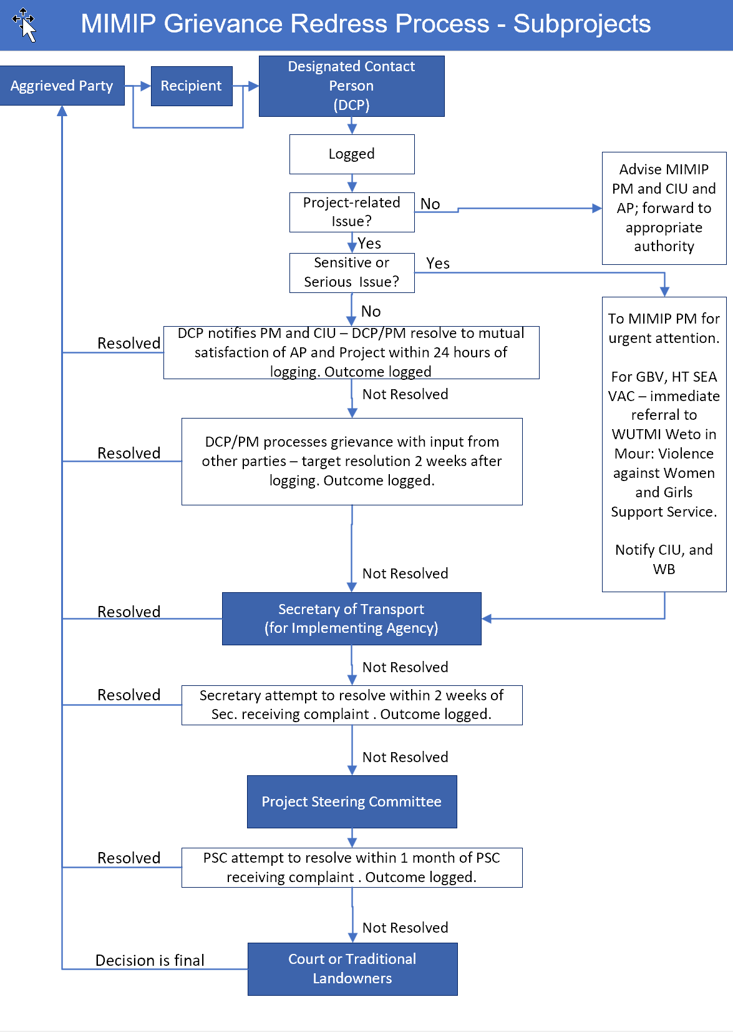

# Gender-Based Violence, Sexual Exploitation, Abuse or Harassment

# Violence against Children and Human Trafficking

**Survivor-Centered Approach**

In all situations involving complaints related to gender-based violence (GBV), sexual exploitation, abuse or harassment (SEAH), violence against children (VAC) and human trafficking (HT), the MIMIP will use a “*survivor-centered approach*”. In line with this approach, the following principles will be systemically applied through all steps and actions:

* The rights, needs, and wishes of the survivor (or victim) is the foremost priority of everyone involved with the project.
* The survivor has a right to:
  + be treated with dignity and respect instead of being exposed to victim-blaming attitudes.
  + choose the course of action in dealing with the violence instead of feeling powerless.
  + privacy and confidentiality instead of exposure.
  + non-discrimination instead of discrimination based on gender, age, race/ ethnicity, ability, sexual orientation, HIV status or any other characteristic.
  + receive comprehensive information to help her make her own decision instead of being told what to do.
* The safety of the survivor shall always be ensured. Potential risks to the survivor will be identified and action taken to ensure the survivor’s safety and to prevent further harm including ensuring that the alleged perpetrator does not have contact with the survivor. If the survivor is an employee, reasonable adjustments may be made to the survivor’s work schedule and work environment to ensure their safety.
* All actions should reflect the choices of the survivor.
* All information related to the case must be kept confidential and identities must be protected. Only those who have a role in the response to an allegation should receive case-level information, and then only for a clearly stated purpose and with the survivor’s consent.
* The survivor must provide informed consent to progress with each stage of the complaints process. Survivors may withdraw their consent at any time during the process.

*The survivor-centered approach aims to create a supportive environment in which the survivor’s rights are respected and in which she is treated with dignity and respect.  The approach helps to promote the survivor’s recovery and her ability to identify and express needs and wishes, as well as to reinforce her capacity to make decisions about possible interventions.*

UN Women

In keeping with the survivor-centered approach, when the MIMIP receives a complaint related to GBV, SEAH, VAC or HT, survivors can be referred to the *WUTMI Weto in Mour: Violence against Women and Girls Support Service* (WUTMI - WIM) to ensure their safety and support needs can be addressed confidentially, professionally and quickly, as long as the survivor agrees. WUTMI - WIM will offer counselling and other forms of assistance to survivors, and explain what other services are available, including legal options. A primary objective is to ensure that victims have the information and support they need to make well informed choices and decisions about their life.

**Procedure for responding to GBV, SEAH, VAC and HT Complaints or Incidents**

All grievances and incidents related to a complaint of GBV, including sexual exploitation, abuse or harassment (SEAH) violence against children (VAC) and human trafficking (HT) need to be managed with a high degree of sensitivity and confidentially.

The MIMIP will act on all complaints of GBV and SEAH which are perpetrated by a project worker or workers, or against a project worker using the following process:

* When a complaint of GBV is received, the person receiving the complaint will complete Form C in confidence and notify the MIMIP Project Director (PD) within 12 hours. The MIMIP Project Director will then:
* Document the complaint or incident within 12 hours using Form B (page 19).
* Determine if the grievance/incident is related to MIMIP or outside the project scope. If not related to the project, the complaint will be referred to WUTMI for follow-up support and the matter will be closed on the MIMIP grievance register.
* If the incident involves MIMIP, the PM shall immediately inform the CIU Manager and Social Safeguards Advisor, the Chair of the Project Steering Committee (PSC) and the World Bank Task Team Leader (TTL).
* The first priority of the PM is to ensure the safety and well-being of the survivor (aka the victim). This includes referring the survivor to WUTMI – WIM and providing any other support service as requested, and recording this on Form B.
* Explain the complaint process to the survivor and gain their consent to continue with the investigation, and record on Form D.
* If the victim chooses to proceed, the MIMIP Manager will review the complaint to determine if a project worker or workers were involved. In making this determination, the Project Director will:
  + - Investigate the complaint to determine what action can be taken.
    - Take disciplinary measures against the alleged perpetrator(s).
* Throughout this process, the MIMIP Manager (or his designate) will continue to communicate with the survivor to inform them of progress in the investigation and ensure the victim consents to each stage of the resolution process. Form D should be completed by the survivor to indicate the preferred method of communication with the Project Director throughout the investigation.

Anonymous complaints

The MIMIP GRM can receive anonymous complaints. The MIMIP GRM can also receive complaints from people who are not the victim themself. However, if the victim does not want to be identified or is not the person making the complaint, the MIMIP GRM is limited in what actions can be taken because it is not possible to ensure the victim’s safety, choice, consent or confidentiality if they are not involved in the process. In these cases, the complaint will be recorded by no specific action will be taken without or until the victim chooses to be involved.

Community or customary dispute resolution

The MIMIP GRM will not participate in community or customary dispute resolution processes or pay compensation to the survivor or anyone else (i.e., their relatives or community) as in most cases these processes do not uphold the survivors’ rights.

# How to Make a Compliant

For further information about the MIMIP or to raise a concern or make a compliant about the Project, please get in touch with any of the following people in person, by phone, mail or by email using this contact information:

**In Person:**

Majuro: Mr. Carl Hacker, MIMIP Project Director

RMIPA Building, Level 2, Delap, Majuro 96960

or

To be Confirmed, Government of RMI (CIU) Safeguards Officer

Uliga, Majuro

Ebeye: Ms. Yumi Crisostomo, Government of RMI (CIU) Safeguards Officer

Finance Office, Kalgov Building, Ebeye

Arno, Jaluit and Wotje: To be provided. *If the concern is related to violence or abuse, please contact your local WUTMI representative*

**By Phone:**

MIMIP Project Manager: Mr. Carl Hacker (692) 456 2958  or (692) 625 8269

MIMIP Support Officer Ms. Celine Aliven (692) 625 8269

DIDA Safeguards Officer: To Be Confirmed To Be Confirmed

DIDA Safeguards Officer: Ms. Yumiko Crisostomo (692) 329 8011

RMIPA Seaports Manager: Captain Robert Heine (692) 625 7613 / 8269

DIDA Safeguards Advisor: Ms. Colleen Peacock (Fiji) (679) 999 4060

**By Email:**

MIMIP Project Director: Mr. Carl Hacker [kadacsh@gmail.com](mailto:kadacsh@gmail.com)

MIMIP Support Officer Ms. Celine Aliven [celinealiven@gmail.com](mailto:celinealiven@gmail.com)

DIDA Safeguards Officer: To Be Confirmed To Be Confirmed

DIDA Safeguards Officer: Ms. Yumiko Crisostomo [mikefamilystore@gmail.com](mailto:mikefamilystore@gmail.com)

DIDA Safeguards Advisor: Ms. Colleen Peacock [colleen@tautai.com](mailto:colleen@tautai.com)

RMIPA Seaports Manager: Captain Robert Heine [rheine96@gmail.com](mailto:rheine96@gmail.com)

**By Mail:**

Project Director, RMIPA, P.O. Box 109, Amata Kabua Blvd. Marshall Islands 96960, or

Safeguards Officer, DIDA, P.O. Box D Majuro, Marshall Islands 96960

**By internet:** <https://www.ciudidasafeguards.com/grm>

# GRM Information Handling and Storage

Every concern or complaint received by the MIMIP Project Director (as DCP) will be allocated a unique File identifier, such as MIMIP GRM – 2022 #1, MIMIP GRM – 2023 #2 etc. A hard copy of the Grievance Report Form will be filed by the DCP in a locked filing cabinet, will be treated as confidential and will not be accessible to other people.

Details of each concern or complaint will be entered into the Project Grievance Registry (See Annex xx) which will be stored by the MIMIP Project Director in a password protected MIMIP Project sub-folder: \\Safeguards\Complaints.

Information relating to GBV, SEAH, HT and VAC will be treated as personal and confidential and only retained by the Project Manager, the CIU Manager and Social Safeguards Specialist, and the PSC Chairperson. Any information shared with the World Bank will have all personal identity information redacted.

Information about the incident will only be made available to WUTMI and approved authorities (such as the police) with the full participation and consent of the survivor.

# Communicating the GRM with Stakeholders

It is intended that MIMIP beneficiaries, and the wider community, are made aware of the project, how to get information, make suggestions and raise concerns. To this end, MIMIP will communicate information about the project and the GRM in the following ways:

|  |  |
| --- | --- |
| Radio | This will involve public notices about the MIMIP, including project goals, activities, and work schedules and how to get further information or raise concerns. |
| Marshall Islands Journal | Newspaper articles will describe the MIMIP, including project goals, activities, and work schedules and how to get further information or raise concerns. |
| Internet | Project information, including grievance procedures will be published on the RMIPA Facebook page and the CIU Safeguards DIDA website.  <https://www.facebook.com/Republic-of-the-Marshall-Islands-Ports-Authority-RMIPA-775546265828801/>  <https://www.ciudidasafeguards.com/grm> |
| Notice Boards | In all areas where physical works is planned, a notice board will be installed outside each operational area, describing the project and identifying how to get further information and raise concerns. |

More information about the project communications is set out in the “*MIMIP Stakeholder Engagement and Communication Action Plan”* available from the Project Manager.

# Reporting and Learning

Reporting on and learning from all grievances and incidents is key to ensuring accountability and improving project performance. As such, the following reports will include a summary of all complaints and incidents related to the implementation of the Maritime Investment Project in the Marshall Islands.

1. **Incident Reports**

* Within 12 hours, the person who receiving the complaint must notify the Project Director (in the case of a complaint related to GBV, complete Form C)
* Within 12 hours, the Project Director must complete the Grievance Form (see Form A and B) and initiate the investigation

**Immediate Reporting to DIDA and the World Bank** (Task Team Leader)by the MIMIP Project Director under the following circumstances:

1. The complaint relates to physical injury or death and the matter is likely linked to the project.
2. The complaint relates to GBV, violence against children or human trafficking and the matter is likely linked to the project.

When notifying the World Bank, only the following information will be shared:

* The nature of the allegation and the circumstances surrounding the incident
* The current well-being of the survivor (is s/he safe from further incidents and does s/he have access to protection and support services
* If the alleged perpetrator is, to the survivor’s best knowledge, associated with the project
* The survivor’s age and/or sex (if available)
* If the survivor has been referred to services.

1. **Monthly Reports**

The Project Director completes monthly reports that summarize any new grievances or incidents, the type of concern, and the number of days it took to resolve the matter. Monthly reports also summarize the status of any outstanding matters from previous months. The names of perpetrators and victims are not included in these reports.

1. **Six-Month Reports**

The Project Director completes a six-report for the General Manager RMIPA, the CIU, the PSC and the World Bank, that contains the following statistics:

* Total number of grievances and complaints received, and how many of those relate to GBV
* Total number of grievances and complaints resolved, including GBV complaints
* Total number of grievances and complaints active, including GBV complaints
* Total number of grievances and complaints unresolved, including GBV incidents
* Average number of days to resolve grievances and complaints.
* Quarterly reports also need to specify any changes the project has made in response to existing or previous complaints.

1. **Annual Reports**

The Project Director completes an annual report summarizing all grievances information for that year. This information is provided to the GM RMIPA, DIDA, the World Bank, and the PSC.

**Note: The names of perpetrators and victims are not included in these reports.**

# Form A: MIMIP Grievance Register Form

|  |  |  |  |
| --- | --- | --- | --- |
| **Grievance Reference #:**  **Electronic file reference #** | | | |
| **Background Information: Summarize Details (attach further pages if necessary):** | | | |
| **Name of Concerned Party:**  (if known) and gender | **Employee ID:**  (If Employee) | | **Telephone:**  **Email:** |
| **Date Concern was raised:** | **Date of 2-week deadline for initial resolution or escalation:** | **Date Complaint Closed:** | |
| **Date, time, and location of event leading to concern:** | | | |
| **Detailed account of the concern (Include names of persons involved) if known (attach further pages if necessary):** | | | |
| **Are there any policies, procedures, guidelines that may have been violated?** *(attach further pages if necessary)* | | | |
| **Proposed solution or sought remedy** *(attach further pages if necessary):* | | | |
| **Outcome of Concern** *(attach further pages if necessary):* | | | |
| **Date and Signature of Entry into Record:**  **Date and Signature of Close-out:** | | | |

# Form B: MIMIP Grievance Register Form for GBV, SEAH, VAC and HT Complaints

***There should be no identifying information included anywhere on this form including survivor and alleged perpetrators names and contact details.***

|  |  |  |  |  |
| --- | --- | --- | --- | --- |
| * + 1. Date complaint was received: | | | | |
| * + 1. Person complaint was received by: | | | | |
| * + 1. Was the person who made the complaint the survivor? | | | | ☐ Yes ☐ No |
| * + 1. Outline the nature of the allegation (what a survivor says in their own words): | | | | |
|  | | | | |
|  | | | | |
|  | | | | |
|  | | | | |
|  | | | | |
| *If it was the survivor who made the complaint answer questions 5 - 9 (if a third party made the complaint, only answer questions 1-4).* | | | | |
| * + 1. To the best of the survivor’s knowledge, is the perpetrator associated with MIMIP? ☐ Yes ☐ No | | | | |  | | ☐ No | |
| * + 1. The age of the survivor (if possible): | | | | |  | | |
| * + 1. The sex of the survivor: ☐ Female ☐ Male ☐ Other ☐ Choose not to answer | | | | |
| * + 1. What services was the survivor referred to (provide name of service): | | | | |
| * + 1. What services was the survivor referred to (provide name of service): | | | | |
| Medical | Yes ☐ | ☐ No ☐ No | Name of Service |  |
| Counseling | Yes ☐ | ☐ N ☐ No | Name of Service |  |
| Safe House | ☐ Yes | ☐ No ☐ No | Name of Service |  |
| Justice | ☐ Yes | ☐ No ☐ No | Name of Service |  |
| Other | ☐ Yes | ☐ No ☐ No | Name of Service |  |
| * + 1. Does the Survivor consent to communicate the allegation to the Project Manager? ☐ Yes ☐ No   *If yes, complete Form C and give to the MIMIP Project Director along with a copy of this completed form.* | | | | |  |

# 

# Form C: Communicate GBV or HT Allegation to MIMIP Project Manager

***This form should only be completed with the consent of the survivor to communicate the allegation to the MIMIP Project Manager***

***_________________________________________________________________________________***

|  |  |
| --- | --- |
| 1. Name of the survivor: |  |
| 1. How does the survivor want the project to contact them to follow-up on the complaint? | |

# Form D: Survivor Consent Form

|  |  |  |  |  |
| --- | --- | --- | --- | --- |
| **Name of Person with Survivor when form was completed** |  | | | |
| **Signature of Survivor or Guardian (for Children under 18)** |  | | | |
| ***Please review the following list with the survivor and ask them to indicate if they agree (check yes) or not agree (check No) to each question.*** | | | | |
| |  | | --- | | **Step 1. Receive the Complaint** | | | | | |
|  | | | Signature of Survivor | Date |
| * 1. Have their complaint documented and registered? | | ☐ Yes ☐ No |  |  |
| * 1. Communicate their complaint to the MIMIP Project Manager? | | ☐ Yes ☐ No |  |  |
| **Step 2. Assess if the allegation is likely linked to the project** | | | | |
| * 1. Share information about the complaint with the contractor / alleged perpetrators employer? | | ☐ Yes ☐ No |  |  |
| * 1. Share information about the complaint with the MoJ? | | ☐ Yes ☐ No |  |  |
| * 1. Share information about the complaint with the World Bank? | | ☐ Yes ☐ No |  |  |
| **Step 3. Verify and Act** | | | | |
| * 1. Be interviewed by the MIMIP Project Director about the complaint? | | ☐ Yes ☐ No |  |  |
| * 1. Share information about the complaint with the alleged perpetrator? | | ☐ Yes ☐ No |  |  |
| * 1. Share information about the complaint with any witnesses? | | ☐ Yes ☐ No |  |  |
| * 1. Share information gathered by the MIMMIP Project Director with other members of the ad hoc committee? | | ☐ Yes ☐ No |  |  |
| **Step 4. Monitor, track, and provide regular reports of the allegation** | | | | |
| * 1. Share which services they were referred to WUTMI and MoJ? | | ☐ Yes ☐ No |  |  |
| * 1. Share what action was taken to resolve the complaint with WUTMI and MoJ? | | ☐ Yes ☐ No |  |  |
| * 1. Ongoing communication from the FSMIP Project Director about the complaint? | | ☐ Yes ☐ No |  |  |

# Form E: World Bank & RMI Government: Project Grievance Register

Name of Project: **xxx** Name and position of person completing Register: **xxx** Date of Last Update: **day/month/year**

Date Register Shared with: CIU: **day/month/year**  PSC: **day/month/year** WB: **day/month/year**

| **When/How Grievance received** | **File #** | **Name of Aggrieved Party** | **Nature of Issue Raised** | **Sensitive or Serious Matter?**  **Yes/No** | **Description & Date of Response & Referral Info** | **Outcome of Response** | **If not resolved, steps taken & date** | **Status**  **(Date of closure or next step)** |
| --- | --- | --- | --- | --- | --- | --- | --- | --- |
| **Date:**  day/month/year  **Method:**  Xx | Name of Project: year: grievance # that year | To be redacted when register is shared | xxx | Yes or No | xxx | xxx | xxx | **Date:**  day/month/year |
| **Date:**  day/month/year  **Method:**  Xx | Name of Project: year: grievance # that year | To be redacted when register is shared | xxx | Yes or No | xxx | xxx | xxx | **Date:**  day/month/year |
| **Date:**  day/month/year  **Method:**  Xx | Name of Project: year: grievance # that year | To be redacted when register is shared | xxx | Yes or No | xxx | xxx | xxx | **Date:**  day/month/year |