Project for Improving Performance in Public Financial Management (PAFiM) Grievance Redress Mechanism (GRM)
Project Overview
The World Bank funded “Improving Performance in Public Financial Management” (PFM) Project is supporting the Government of the Marshall Islands to improve their financial management information system for better reliability and timeliness of government information, including financial reporting and statistics. The Project is also helping to build human resource capacity and strengthen management in the Ministry of Finance. The PFM Project will operate from 2018 to 2023.
What is a Grievance Redress Mechanism?
A grievance redress mechanism (GRM) is the process of raising issues about a project or making a complaint about a project and ensuring it is fully investigated and addressed in a fair and timely manner. The PFM GRM is illustrated in the following Figure. A GRM recording form is also attached.
Key Features of the Project GRM
- It only deals with PFM Project related matters.
- It covers the entire duration of the Project because questions, concerns or complaints can arise any time.
- It can be used by anyone who has a concern or a complaint about the Project. Grievances can be raised in an open and public manner, or privately and in-confidence. The identity of the person who makes a complaint will be kept confidential.
- There are different kinds of concerns that could arise during PFM implementation including “series or sensitive” matters such as potential criminal activity like misuse of project funds or assets and allegations of gender-based violence by Project personnel.
- The PFM GRM is not a substitute for legal or other public or civic resolution mechanisms and does not remove people’s right to take their grievance to a formal dispute-resolution mechanism. This GRM will not interfere with any formal legal proceedings.
- The PFM Project Manager, who has overall responsibility for making sure the GRM operates properly, is referred to as the “Designated Contact Person” (DCP) and will stay involved until the matter is resolved. The Program Manager is also responsible for keeping the RMI Government and the World Bank informed about the nature of all grievances, while keeping the names of people involved with the complaint confidential.
What should people do if they have a complaint about the Project?
If you, or someone you know, has a concern about the Project, please contact the PFM Project Manager or the CIU Safeguards Officer at DIDA, Ministry of Finance so an investigation can be conducted, and the matter resolved as quickly as possible.
- Lynda Roades: PFM Acting Project Manager, Ministry of Finance
Phone: (692) 457 5872 or 625 5968 Email: lynda@roadesadvisory.com

- Jessica Zebedee: Safeguards Officer, Ministry of Finance
Phone: (692) 456 5233 or 625 5968 Email: jess.zebedee@gmail.com
Mail: PFM, Ministry of Finance, P O Box D Majuro, MH 96960, RMI
Internet: rmi-mof.com/division-of-international-development-assistance/news-and-updates/
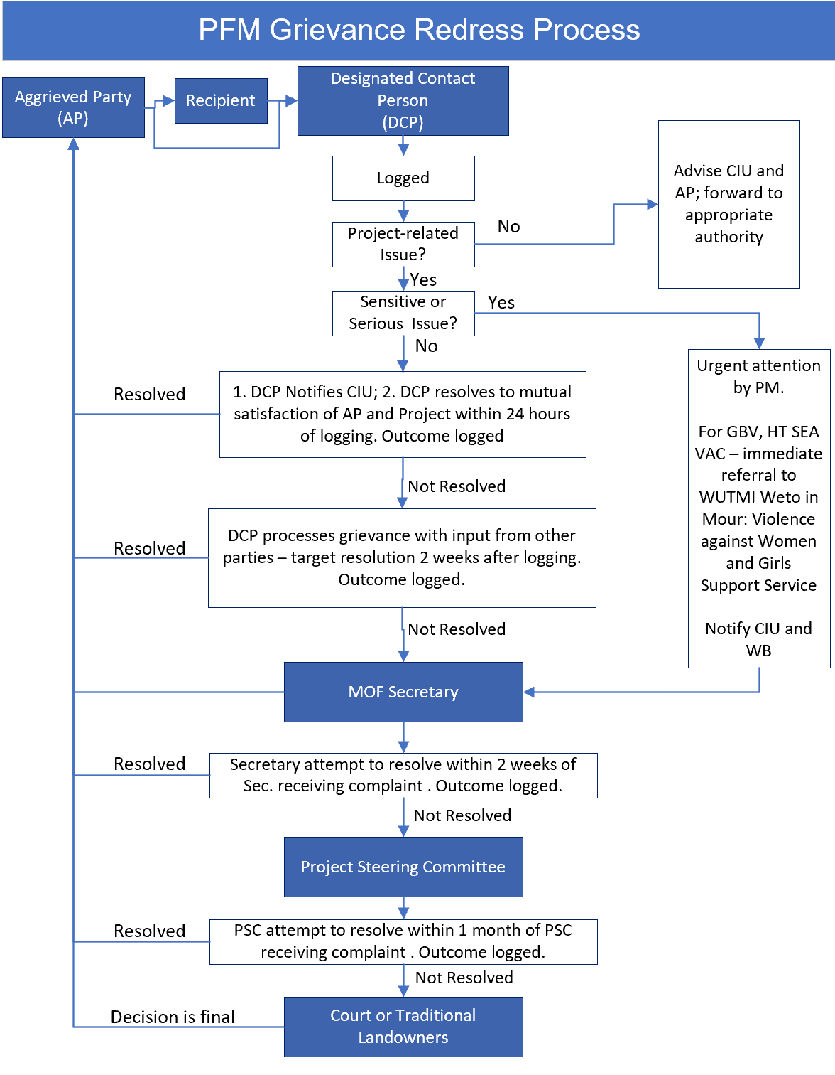
PFM GRIEVANCE REPORT FORM

Grievance Reference #:

Electronic file reference #
Background Information: Summarize Details (attach further pages if necessary):

Note: If the complaint is related to gender-based violence (GBV), sexual exploitation, abuse or sexual harassment (SEAH) or violence against children (VAC), the situation must be immediately referred to the WUTMI Weto in Mour: Violence against Women and Girls Support Service (WIM). (WUTMI (if concern is about project related violence or abuse) wetoinmour@wutmi.com or (692) 625-6687

 | Name of concerned party (or anonymous) and gender | Employee ID (If  Employee) |  | Telephone  Email
Date of Raising of Concern |  | Date of 2 week deadline for initial resolution or escalation: | Actual date of close out:
 | Date, time, and location of Event leading to Concern:
 | Detailed account of the concern (Include names of persons involved) if known (attach further pages if necessary):
 | Are there any policies, procedures, guidelines that may have been violated (attach further pages if necessary):
 | Proposed solution or sought remedy (attach further pages if necessary):
 | Outcome of Concern (attach further pages if necessary):
Date and Signature of Entry into Record:

Date and Signature of Close-out:

