Republic of Marshall Islands Maritime Investment Project

Benthic Marine Environment Description of Areas Within and Adjacent to the Proposed Physical Investments

Contents

Part One: Methods used to Assess Benthic Habitats and Technical Considerations 4

Part Two: Benthic Environment Description 5

Jaluit Port 5

Jaluit Port, Benthic Environment Executive Summary 5

Jaluit Port Benthic Sampling Overview 5

Jaluit Port Benthic Environment Description 6

Ebeye Port 9

Ebeye Port, Benthic Environment Executive Summary 9

Ebeye Port Benthic Sampling Overview 9

Ebeye Port, Benthic Environment Description 10

Delap Port, Majuro 12

Delap Port, Majuro, Benthic Environment Executive Summary 12

Delap Port, Majuro, Benthic Sampling Overview 13

Delap Port, Majuro, Benthic Environment Description 15

Uliga Port, Majuro 18

Uliga Port, Majuro, Benthic Environment Executive Summary 18

Uliga Port, Majuro, Benthic Sampling Overview 18

Uliga Port, Majuro, Benthic Environment Description 20

Part Three: Project Marine Environmental Risks 23

References 24

Appendix 1 – Benthic Habitat/Taxonomic Group Categories Used to Describe Benthic Environments 25

Figure 1 Basic sampling scheme for benthic surveys of Jaluit Port. Note, the seaward length of the west facing dock is included, but otherwise diagram is not to scale. 5

Figure 2 Percent cover of main benthic substrate categories at each surveyed site at Jaluit Port. Values are mean values based on stratified random point sampling of individual photo quadrats according the sampling summarized in Table 1. Whiskers on bars are Standard Error of the mean 7

Figure 3 Representative photos of the benthic environment of each surveyed site at Jaluit Port 8

Figure 4 Basic sampling scheme for benthic surveys of Ebeye Port. Sampling sites are indicated by named purple circles and approximate depths are given in parentheses. Note, the length of the seaward (western) port bib is shown, but otherwise diagram is not to scale 9

Figure 5 Percent cover of main benthic substrate categories at each surveyed site at Ebeye Port. Values are mean values based on stratified random point sampling of individual photo quadrats, summarized by transect, according the sampling summarized in Table 1. Whiskers on bars are Standard Error. 11

Figure 6 Representative photos of the benthic environment of each surveyed site at Ebeye Por 12

Figure 7 Basic sampling scheme for benthic surveys of Delap Port. Sampling sites are indicated by named purple circles and approximate depths are given in parentheses. Note, the length of the seaward (western) port bib is shown, but otherwise diagram is not to scale 13

Figure 8 Percent cover of main benthic substrate categories at each surveyed site at Delap Port. Values are mean values based on stratified random point sampling of individual photo quadrats, summarized by transect, according the sampling summarized in Table 1. Whiskers on bars are Standard Error of the mean 16

Figure 9 Representative photos of the benthic environment of each surveyed site at Delap Port 17

Figure 10 Basic sampling scheme for benthic surveys of Uliga Port. Sampling sites are indicated by named purple circles and approximate depths are given in parentheses. Note, the length of the seaward (western) port bib is shown, but otherwise diagram is not to scale. 18

Figure 11 Percent cover of main benthic substrate categories at each surveyed site at Uliga Port. Values are mean values based on stratified random point sampling of individual photo quadrats, summarized by transect, according the sampling summarized in Table 1. Whiskers on bars are Standard Error of the mean 21

Figure 12Some representative photos of the benthic environment of each surveyed site at Uliga Port. 22

Table 1 Sampling summary of benthic surveys at Jaluit Port. See Figure 1 for schematic of sampling areas in relation to the port. 6

Table 2 Mean coverage of macro-abiotic substrate categories at Jaluit Port. Values are mean values (Standard Error Mean) based on stratified random point sampling of individual photo quadrats according the sampling summarized in Table 1. 7

Table 3 Sampling effort summary of benthic surveys at Ebeye Port. See Figure 4 for schematic of sampling areas in relation to the port. 10

Table 4 Mean coverage of abiotic substrate categories at the Ebeye Port. Values are mean values (Standard Error) based on stratified random point sampling of individual photo quadrats according the sampling summarized in Table 3. 11

Table 5 Sampling effort summary of benthic surveys at Delap Port. See Fig 1. for schematic of sampling areas in relation to the port 14

Table 6 Mean coverage of abiotic substrate categories at Delap Port. Values are mean values (Standard Error) based on stratified random point sampling of individual photo quadrats according the sampling summarized in Table 5. 16

Table 7 Sampling effort summary of benthic surveys at Uliga Port. See Figure 10 for schematic of sampling areas in relation to the port 19

Table 8 Mean coverage of abiotic substrate categories at Uliga Port. Values are mean values (Standard Error) based on stratified random point sampling of individual photo quadrats according the sampling summarized in Table 7. 21

# Part One: Methods used to Assess Benthic Habitats and Technical Considerations

A number of factors dictated the methods used to describe the benthic marine environment within and adjacent to the areas of the proposed physical investments. Because of the extremely tight timelines for the work (both in terms of field work, and also reporting) and the fact that associates of various levels of professional ability were engaged locally, we employed a simple photographic technique to document benthic environments, that employs easy to use waterproof cameras (most GoPro Hero 7) taking unframed quadrat photographs along randomly placed 30m transects at within and adjacent to Ports. These photos are then analyzed using ‘random point count’ methodology, which is a common method to enumerate community/habitat statistics in a variety of fields of biology (Kohler and Gill, 2006), and commonly used for coral reef habitats (Carleton and Done 1995). This method allowed many sites to be assessed quickly and quantitatively using basic habitat descriptors. However, the broad overview of marine benthic habitats this method has produced is by no means a comprehensive biological/ecological inventory and should only be used for semi-quantitative descriptive purposes rather than representing a current biological baseline dataset.

At each port the site was initially assessed both from satellite photographs and then *in situ*. Survey sites were selected for data collection to assess the benthic environment based on both proximity to the physical investments (directly around ports) and adjacent to ports, based on the variety of habitats present (i.e. deep channels, fringing reef slopes, reef flats, intertidal areas etc). At each site two divers (or a single snorkeler) were deployed. The diver/snorkeler randomly placed the start of a 50m surveyors measuring tape on the bottom and deployed 30m of tape in a random direction. The diver (or a second diver) then swam along the transect length, taking 8-15 photographs of the seafloor from directly above the transect tape with the transect tape in-shot. This was performed 4-8 times per site, depending on logistical restraints. At one port (Uliga), instead of transects being deployed at a single survey site, a drop-camera was used to take 24 random 1m x 1m photo quadrats throughout the broader area.

Photos were analyzed using the program CPCe (Kohler and Gill, 2006), which allows users to correctly spatially scale photographs according to known measures (in this case the surveyors tape). The program then has an algorithm to place random points within a pre-defined area (the photo quadrat area), and database functions that allow the user to catalog the benthic habitat category/taxonomic group under individual datapoints. For this study, photographs had a quadrat (area of predefined dimension) defined based on as large an area as practical given the field of view of the photograph. The usual quadrat size was usually approximately 1m x 1m, however for some ports surveyed by snorkel (Jaluit and Ebeye), quadrats of up to 7m x 1m were used because of limitations with the field of view of the photograph. Within each quadrat a point was placed at random in each 10cm column of the quadrat, and the user then recorded the benthic habitat category/taxonomic group at this point. Habitat categories and taxonomic groupings used to record data for this report are provided below in Appendix 1.

After data was collected for each site, data were summarized per transect such that descriptive statistics (means, standard deviations, standard errors) were generated across transects (or quadrats for the drop-camera at Uliga). Benthic habitat data is presented in graph and table form however all data (photographs, CPCe outputs) is available in electronic appendices.

# Part Two: Benthic Environment Description

## Jaluit Port

### Jaluit Port, Benthic Environment Executive Summary

The port at Jaluit is situated on the leeward, lagoon shore on the southern corner of Jaluit atoll. Excepting the fringing reef around 80m to the NNW of the port, its benthic habitat is predominately macro-abiotic, consisting mostly of coarse sand with sparse visible epiflora or fauna. The area immediately to the west of the port dock has < 10% biotic substrate cover and recedes westward into deeper lagoon habitat. The benthic habitat immediately north of the port consists of small sandy channel which meets a shallow fringing reef habitat abutting the western shoreline of Jaluit. The fringing reef slop is dominated hard substrate with algal turf and relatively high hard-coral cover (≈36%). The shallow lagoon to the south and east of the port dock consists mostly of coarse sand, however sparse hard coral colonies are present (≈10% cover). A quantitative description of the benthic habitats around and immediately adjacent to the port is presented in detail below. The port area appears to already be impacted by port and maritime activity, given the prevalence of industrial and domestic waste on the seafloor. The proposed project appears to pose little threat to the existing marine benthic environment, however some general recommendations, revolving around pollution management are provided considering the likely industrial operations associated with the project and as a result of potentially increased future port capacity and/or use.

### Jaluit Port Benthic Sampling Overview

The dock at Jaluit was sampled at one location on the widest north-western facing area of the dock (Sites 1 and 2; Figure 1), two locations adjacent to the dock (Site 1 and Site 4; Figure 1) as well as two close-by locations, one where benthic habitat transitioned from a deeper lagoon to a fringing reef slope and reef flat environment (Site 2; Fig 1) and the other with shallow (<5m) lagoon sandflats and scattered hard corals (Site 5; Figure 1). In total, the benthic habitat was quantitatively characterized at 1756 randomly selected points from 101 photo-quadrats, representing a random selection of 175.8m2 of benthic habitat,from 510 linear meters of haphazardly placed 30m (*n*=17) transects (Figure 1;

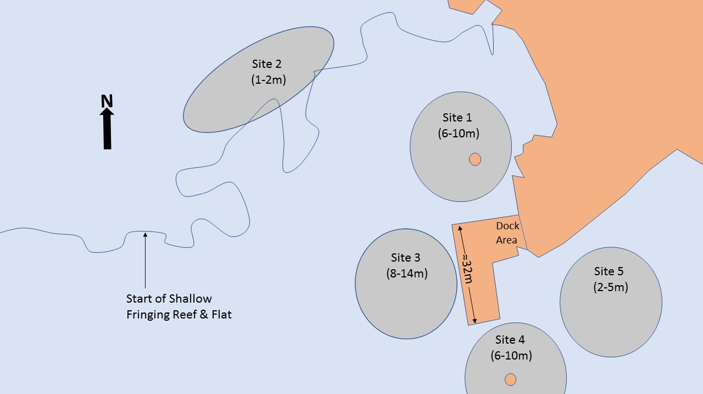

Figure 1 Basic sampling scheme for benthic surveys of Jaluit Port. Note, the seaward length of the west facing dock is included, but otherwise diagram is not to scale.

Table 1 Sampling summary of benthic surveys at Jaluit Port. See Figure 1 for schematic of sampling areas in relation to the port.

|  |  |  |  |  |  |  |  |
| --- | --- | --- | --- | --- | --- | --- | --- |
| Site | Transect | Total Data Points | Total M2 Surveyed | # Photo Quadrats | Mean (M2) Quadrat Size | Min (M2) Quadrat Size | Max (M2) Quadrat Size |
| 1 | 1 | 130 | 13 | 6 | 2.17 | 2 | 3 |
| 1 | 2 | 122 | 12 | 6 | 2.03 | 2 | 2 |
| 1 | 3 | 92 | 9 | 4 | 2.3 | 2 | 3 |
| 1 | **Totals** | **344** | **34** | **16** |  |  |  |
| 2 | 1 | 104 | 9.88 | 8 | 1.3 | 0.8 | 2 |
| 2 | 2 | 68 | 7.9 | 7 | 0.97 | 0.6 | 2 |
| 2 | 3 | 80 | 8 | 8 | 1 | 1 | 1 |
| 2 | 4 | 80 | 8 | 8 | 1 | 1 | 1 |
| 2 | **Totals** | **332** | **33.78** | **31** |  |  |  |
| 3 | 1 | 120 | 12 | 6 | 2 | 2 | 2 |
| 3 | 2 | 120 | 12 | 6 | 2 | 2 | 2 |
| 3 | **3** | 60 | 6 | 3 | 2 | 2 | 2 |
| 3 | Totals | 300 | 30 | 15 |  |  |  |
| 4 | 1 | 80 | 8 | 4 | 2 | 2 | 2 |
| 4 | 2 | 120 | 12 | 6 | 2 | 2 | 2 |
| 4 | 3 | 100 | 10 | 5 | 2 | 2 | 2 |
| 4 | **Totals** | **300** | **30** | **15** |  |  |  |
| 5 | 1 | 120 | 12 | 6 | 2 | 2 | 2 |
| 5 | 2 | 120 | 12 | 6 | 2 | 2 | 2 |
| 5 | 3 | 120 | 12 | 6 | 2 | 2 | 2 |
| 5 | 4 | 120 | 12 | 6 |  |  |  |
| 5 | **Totals** | **480** | **48** | **24** |  |  |  |
|  | **Transect** | **Total Data Points** | **Total M2 Surveyed** | **# Photo Quadrats** |  |  |  |
| Jaluit - Totals | **17** | **1756** | **175.78** | **101** |  |  |  |

### Jaluit Port Benthic Environment Description

The dock at Jaluit is on the leeward, lagoon shore of Jaluit Island on the southern corner of Jaluit atoll. The depth around the main operational port area (the western side of the dock) is around 8-14m, which falls away rapidly to the west to deep lagoon, sandy bottom habitat. The benthic habitat immediately surrounding the north, west and south of the dock at Jaluit was dominated by abiotic substrate with very little epiflora and epifauna visible (Sites 1, 3, and 4; Figure 2). The majority of abiotic substrate consisted of course sand, bare rubble and litter at sites 1 & 3 (Table 2). Coarse sand at all sites showed clear signs it is composed of the calcareous remains of *Halimeda spp*., which is a common feature of marine sediments in atoll and lagoonal reef environments with *Halimeda spp.* present (Hoek et al. 1995). Except for Site 4, which also had ≈27 +/- 9% cover (mean +/- SEM) of hard substrate (mostly rubble) with turf algae, the little biotic benthic cover present at these sites (<10%) was generally macroalgae (mostly *Halimeda spp*) or sparse colonies of hard coral at Sites 1 and 3 (mostly *Montipora* sp.).

The reef slope immediately to the NNW of the dock (Site 2; Figure 1) was dominated by hard substrate, either algal turf covered rubble/dead coral (≈50%) or hard coral (≈37%). Hard coral present at site 2 was almost exclusively *Monitpora sp.*. (see Site 2, Figure 3 for example) and most macroalgae present was *Padina sp.*, albeit at low cover (<≈5%).

The shallow lagoon area at site 5 (Figure 1) was mostly macro-abiotic, predominately sandy bottom (Figure 2; Table 2), however there was also around 10% hard coral cover consisting mostly of isolated branching growth form *Acropora spp.* colonies (See Site 5, Figure 3 for example).

Litter/refuse of both industrial and domestic origin was noted at all sites except Site 2, the reef slope immediately to the NNW of the dock and was also point-scored in quadrats all sites except site 2 (Table 2).

Figure 2 Percent cover of main benthic substrate categories at each surveyed site at Jaluit Port. Values are mean values based on stratified random point sampling of individual photo quadrats according the sampling summarized

in Table 1. Whiskers on bars are Standard Error of the mean

Table 2 Mean coverage of macro-abiotic substrate categories at Jaluit Port. Values are mean values (Standard Error Mean) based on stratified random point sampling of individual photo quadrats according the sampling summarized in Table 1.

|  |  |  |  |  |  |  |  |  |
| --- | --- | --- | --- | --- | --- | --- | --- | --- |
|  | Bare Rock (BARERO) | Bare Rubble (BARERU) | Course Sand (CSAND) | Fine Sand (FSAND) | Litter Industrial (LITI) | Litter domestic (LITD) | NON-CORAL Bolder/Rock (BOLD) | Silt/MUD (SILT) |
| Site 1 | 1.38 (0.9) | 16.00 (7.0) | 56.47 (5.9) | 0.00 (0.0) | 0.87 (0.5) | 11.86 (1.9) | 0.00 (0.0) | 0.00 (0.0) |
| Site 2 | 0.00 (0.0) | 6.36  (1.8) | 0.00 (0.0) | 0.00 (0.0) | 0.00 (0.0) | 0.00 (0.0) | 0.00 (0.0) | 0.00 (0.0) |
| Site 3 | 0.00 (0.0) | 1.13  (1.1) | 79.95 (9.3) | 0.00 (0.0) | 0.00 (0.0) | 9.32 (7.3) | 0.00 (0.0) | 0.00 (0.0) |
| Site 4 | 0.00 (0.0) | 12.32 (6.6) | 57.84 (11.7) | 0.00 (0.0) | 0.00 (0.0) | 2.15 (0.8) | 0.00 (0.0) | 0.00 (0.0) |
| Site 5 | 0.00 (0.0) | 11.13 (9.5) | 71.87 (10.8) | 1.47 (1.5) | 0.00 (0.0) | 0.63 (0.4) | 0.00 (0.0) | 0.00 (0.0) |

Representative images of all sites surveyed at Jaluit are shown in Figure 3.

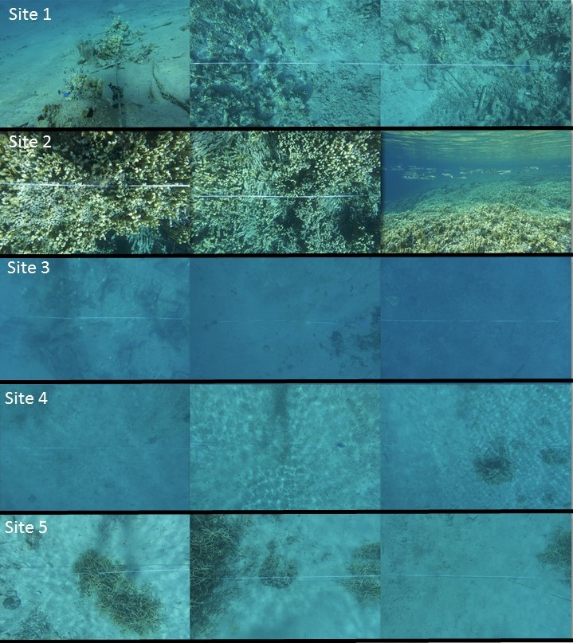

Figure 3 Representative photos of the benthic environment of each surveyed site at Jaluit Port

## Ebeye Port

### Ebeye Port, Benthic Environment Executive Summary

The dock at Ebeye is on the leeward, lagoon shore of Ebeye Island on the southern corner of Kwajalein atoll. The depth around the main operational port area (the western side of the dock) is around 12-17m, which falls away rapidly to the west to deep lagoon, sandy bottom habitat. The existing benthic habitat at the main operational area and to the north of Ebeye port predominately consists of both macroalgae (*Halimdea* sp. meadows) and macro-abiotic substrate (mostly coarse sand, bare rubble and litter/refuse) with sparse visible epifauna. The area immediate south and SSE of the port is a shallow lagoon area abutting the western shore of Ebeye Island. The shallow lagoon area is where the substrate transitions to higher algal turf cover and there is also sparse hard coral cover of ≈<5%. A quantitative description of the benthic habitats around and immediately adjacent to the port is presented in detail below. The area appears to already be impacted by industrial activity, given the prevalence of industrial and domestic waste on the seafloor. The proposed project appears to pose little threat to the existing marine benthic environment, however some general recommendations, revolving around pollution management are provided considering the likely industrial operations associated with the project and as a result of potentially increased future port capacity and/or use.

### Ebeye Port Benthic Sampling Overview

The port at Ebeye was sampled at two sites on the widest western facing area of the dock (Sites 1, 2; Fig 4), one site on the southern side of the main dock in shallow lagoon sandflats leading up to a close fringing reef (Site 3; Fig 4) and one site on the northern side of the main port area, which was shallower than the main operational area of the port (Site 4; Fig. 4)). In total, the benthic habitat was quantitatively characterized at 2044 randomly selected points from 68 photo-quadrats, representing a random selection of 201 m2 of benthic habitat,from 390 linear meters of haphazardly placed 30m (*n*=13) transects (Table 3).

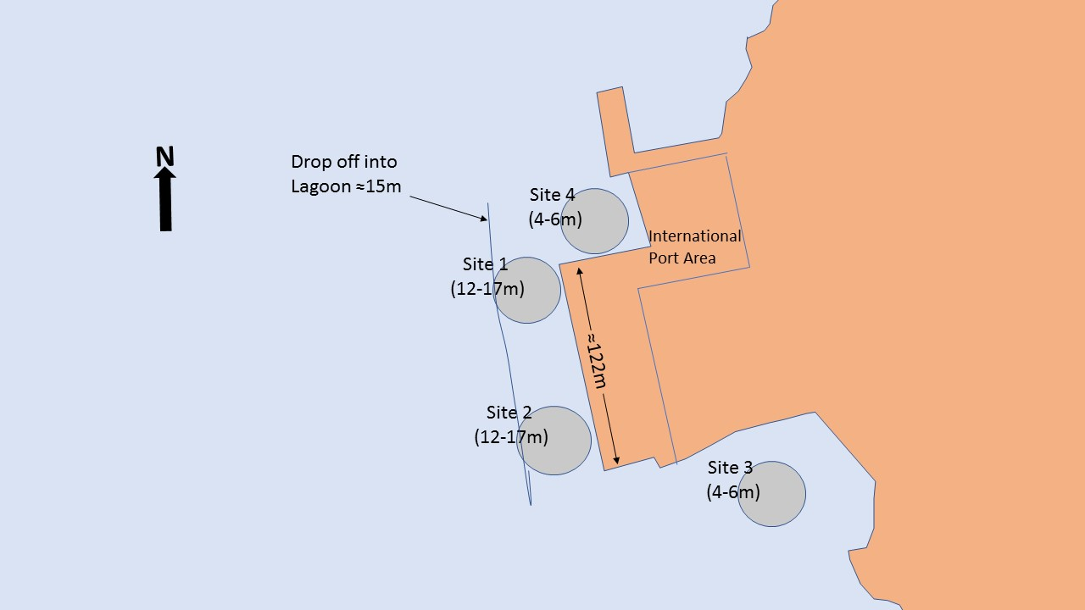

Figure 4 Basic sampling scheme for benthic surveys of Ebeye Port. Sampling sites are indicated by named purple circles and approximate depths are given in parentheses. Note, the length of the seaward (western) port bib is shown, but otherwise diagram is not to scale

Table 3 Sampling effort summary of benthic surveys at Ebeye Port. See Figure 4 for schematic of sampling areas in relation to the port.

|  |  |  |  |  |  |  |  |
| --- | --- | --- | --- | --- | --- | --- | --- |
| Site | Transect | Total Data Points | Total m2 Surveyed | # Quadrats | Mean (M2) Quadrat Size | Min (M2) Quadrat Size | Max (M2) Quadrat Size |
| 1 | 1 | 224 | 19 | 5 | 4.48 | 3 | 7 |
| 1 | 2 | 180 | 18 | 5 | 3.6 | 3 | 4 |
| 1 | 3 | 100 | 10 | 2 | 5 | 3 | 7 |
| 1 | 4 | 100 | 10 | 2 | 5 | 4 | 6 |
| 1 | **Totals** | **604** | **57** | **14** |  |  |  |
| 2 | 1 | 210 | 21 | 6 | 3.5 | 3 | 4 |
| 2 | 2 | 150 | 15 | 5 | 3 | 2 | 4 |
| 2 | 3 | 150 | 15 | 5 | 3 | 3 | 3 |
| 2 | **Totals** | **510** | **51** | **16** |  |  |  |
| 3 | 1 | 240 | 24 | 8 | 3 | 3 | 3 |
| 3 | 2 | 160 | 16 | 6 | 2.67 | 2 | 3 |
| 3 | 3 | 140 | 14 | 6 | 2.33 | 2 | 3 |
| 3 | 4 | 160 | 16 | 6 | 2.67 | 2 | 3 |
| 3 | **Totals** | **700** | **70** | **26** |  |  |  |
| 4 | 1 | 120 | 12 | 6 | 2 | 2 | 2 |
| 4 | 2 | 110 | 11 | 6 | 1.83 | 1 | 2 |
| 4 | **Totals** | **230** | **23** | **12** |  |  |  |
|  | **Transects** | **Total Data Points** | **Total m2 Surveyed** | **# Quadrats** |  |  |  |
| Ebeye Totals | 13 | 2044 | 201 | 68 |  |  |  |

### Ebeye Port, Benthic Environment Description

The dock at Ebeye is on the leeward, lagoon shore of Ebeye Island on the southern corner of Kwajalein atoll. The depth around the main operational port area (the western side of the dock) is around 12-17m, which falls away rapidly to the west to deep lagoon, sandy bottom habitat. Excepting shallow lagoon abutting the island shore immediately to the south of the main port area (Site 3), the benthic habitat surrounding and adjacent to Ebeye port (within 100m), was dominated by both macro-abiotic substrate (coarse *Halimeda spp*. sands – 40-55% cover; Figure 5) and macroalgae (mostly *Halimeda spp*. meadows - ≈40% cover; Figure 5). At Sites 1 and 2 off the main operational area of the port, ≈10% of benthic cover was industrial litter/refuse (Table 4). At these sites (usually < 3% cover) there were also several uncommonly large bryozoan colonies (See Site 1 and Site 2; Figure 5). The presence of such bryozoan colonies, along with the depth of the area, suggests the benthic environment is likely to not be affected with continual suspension of sediment from ships props during movements etc.

At Site 3, the shallow lagoon abutting the island shore immediately to the south of the main port area, the benthic environment was dominated by macro-abiotic substrate (fine and coarse sands, ≈40% cover; Figure 5, Table 4) and algal turf covered rubble and dead coral (≈30% cover; Figure 5). There was also considerable cover of *Halimeda spp.* (≈20% cover; Figure 5) but much less than in other areas surveyed at Ebeye. There were also some hard corals present (≈6% cover; Figure 5), the hard-coral taxa noted were mostly branching growth form *Porites sp,* some *Pocillopora sp* and a few solitary growth form *Fungia sp,*

Three juvenile manta rays were also observed while conducting benthic surveys (two at Site 1, one at Site 3).

As with other RMI ports, litter/refuse of both industrial and domestic origin was noted at all locations and was point-scored in quadrats at all sites except for Site 4 (Table 4).

Figure 5 Percent cover of main benthic substrate categories at each surveyed site at Ebeye Port. Values are mean values based on stratified random point sampling of individual photo quadrats, summarized by transect, according the sampling summarized in Table 1. Whiskers on bars are Standard Error.

Table 4 Mean coverage of abiotic substrate categories at the Ebeye Port. Values are mean values (Standard Error) based on stratified random point sampling of individual photo quadrats according the sampling summarized in Table 3.

|  |  |  |  |  |  |  |  |  |
| --- | --- | --- | --- | --- | --- | --- | --- | --- |
|  | Bare Rock (BARERO) | Bare Rubble (BARERU) | Course Sand (CSAND) | Fine Sand (FSAND) | Litter Industrial (LITI) | Litter domestic (LITD) | NON-CORAL Bolder/Rock (BOLD) | Silt/MUD (SILT) |
| Site 1 | 1.01 (1.0) | 9.72  (3.1) | 21.04 (3.7) | 0.00 (0.0) | 8.83 (4.4) | 1.21 (0.8) | 0.00 (0.0) | 0.00 (0.0) |
| Site 2 | 0.45 (0.2) | 14.80 (4.4) | 21.09 (1.8) | 0.00 (0.0) | 10.30 (1.9) | 0.84 (0.6) | 0.00 (0.0) | 0.00 (0.0) |
| Site 3 | 0.00 (0.0) | 2.02  (0.8) | 7.18 (2.5) | 31.73 (14.4) | 0.00 (0.0) | 0.16 (0.2) | 0.00 (0.0) | 0.00 (0.0) |
| Site 4 | 0.00 (0.0) | 0.00  (0.0) | 53.66 (13.8) | 0.00 (0.0) | 0.00 (0.0) | 0.00 (0.0) | 0.00 (0.0) | 0.00 (0.0) |

Some representative images of all sites at Ebeye are shown in Figure 6.

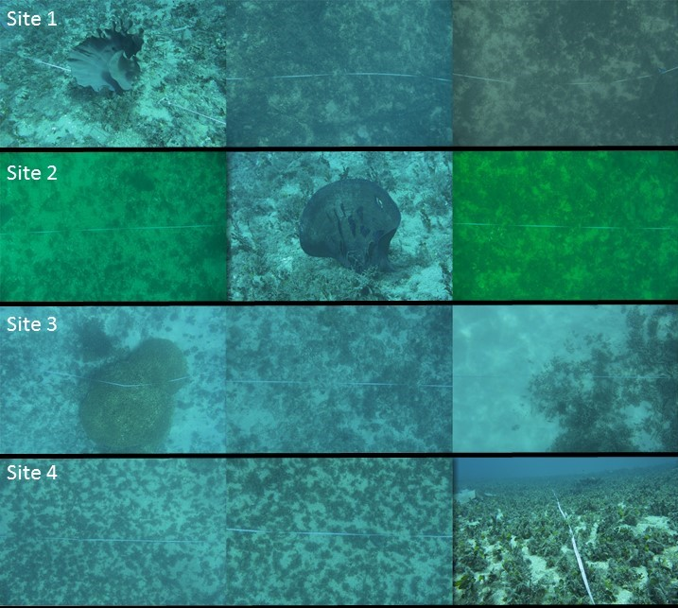

Figure 6 Representative photos of the benthic environment of each surveyed site at Ebeye Por

## Delap Port, Majuro

### Delap Port, Majuro, Benthic Environment Executive Summary

Delap Port is on the leeward, southern lagoon shore of the large Island on the eastern corner of Majuro atoll. The benthic habitat is predominately macro-abiotic at the main operational area (the northern facing dock), consisting mostly of coarse sand, bare rubble and litter/refuse, with sparse visible epiflora or fauna. This area rapidly changes to deep lagoon habitat to the north via a sandy slope. The area immediately to the east of the port dock is also an operationally busy area with a shallow lagoon benthic habitat: abundant macroalgae (≈30% cover) sparse individual hard coral colonies, and coarse sand. To the west of the port the benthic habitat transitions from a deeper lagoon environment to a fringing reef flat environment, although mostly consisting of algal turf covered hard substrate with sparse hard coral cover. A quantitative description of the benthic habitats around and immediately adjacent to the port is presented in detail below. The port area appears to already be impacted by industrial activity, given the prevalence of industrial and domestic waste on the seafloor. The proposed project appears to pose little threat to the existing marine benthic environment, however some general recommendations, revolving around pollution management are provided considering the likely industrial operations associated with the project and as a result of potentially increased future port capacity and/or use.

### Delap Port, Majuro, Benthic Sampling Overview

Delap Port, Majuro was sampled at two sites on the widest northern facing area of the dock (Sites 1 and 2; Figure 7), one site on the eastern site of the main port area, where benthic habitat transitioned from deep lagoon to shallow lagoon (Site 3; Figure 7) and one site on the western side of the main port area where benthic habitat transitioned from a deeper lagoon environment to a fringing reef flat environment (Sites 4 and 4a; Figure 7i). In total, the benthic habitat was quantitatively characterized at 2152 randomly selected points from 216 photo-quadrats, representing a random selection of 214.5 m2 of benthic habitat,from 810 linear meters of haphazardly placed 30m (*n*=27) transects (Table 5).

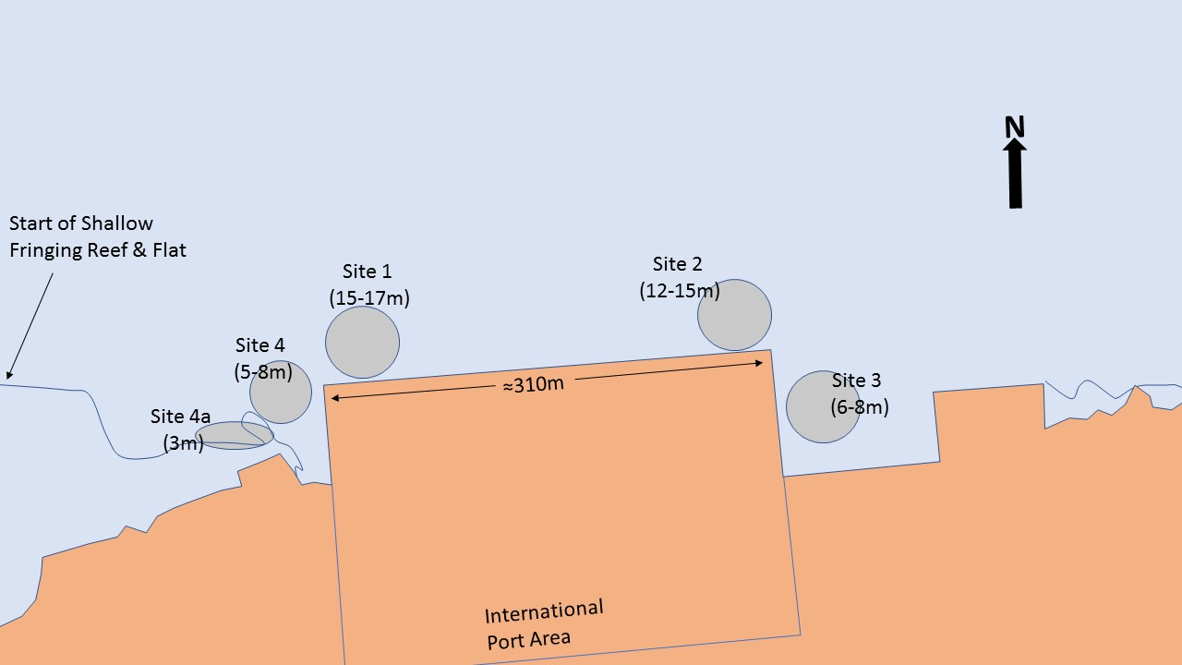

Figure 7 Basic sampling scheme for benthic surveys of Delap Port. Sampling sites are indicated by named purple circles and approximate depths are given in parentheses. Note, the length of the seaward (western) port bib is shown, but otherwise diagram is not to scale

Table 5 Sampling effort summary of benthic surveys at Delap Port. See Fig 1. for schematic of sampling areas in relation to the port

|  |  |  |  |  |  |  |  |
| --- | --- | --- | --- | --- | --- | --- | --- |
| Site | Transect | Total Data Points | Total m2 Sampled | # Quadrats | Mean (M2) Quadrat Size | Min (M2) Quadrat Size | Max (M2) Quadrat Size |
| 1 | 1 | 80 | 8 | 8 | 1 | 1 | 1 |
| 1 | 2 | 80 | 8 | 8 | 1 | 1 | 1 |
| 1 | 3 | 80 | 8 | 8 | 1 | 1 | 1 |
| 1 | 4 | 80 | 8 | 8 | 1 | 1 | 1 |
| 1 | **Totals** | **320** | **32** | **32** |  |  |  |
| 2 | 1 | 79 | 7.81 | 8 | 0.99 | 0.9 | 1 |
| 2 | 2 | 75 | 7.13 | 8 | 0.94 | 0.7 | 1 |
| 2 | 3 | 79 | 7.81 | 8 | 0.99 | 0.9 | 1 |
| 2 | 4 | 79 | 7.81 | 8 | 0.99 | 0.9 | 1 |
| 2 | 5 | 80 | 8 | 8 | 1 | 1 | 1 |
| 2 | 6 | 80 | 8 | 8 | 1 | 1 | 1 |
| 2 | 7 | 80 | 8 | 8 | 1 | 1 | 1 |
| 2 | 8 | 80 | 8 | 8 | 1 | 1 | 1 |
| 2 | **Totals** | **632** | **62.56** | **64** |  |  |  |
| 3 | 1 | 80 | 8 | 8 | 1 | 1 | 1 |
| 3 | 2 | 80 | 8 | 8 | 1 | 1 | 1 |
| 3 | 3 | 80 | 8 | 8 | 1 | 1 | 1 |
| 3 | 4 | 80 | 8 | 8 | 1 | 1 | 1 |
| 3 | 5 | 80 | 8 | 8 | 1 | 1 | 1 |
| 3 | 6 | 80 | 8 | 8 | 1 | 1 | 1 |
| 3 | 7 | 80 | 8 | 8 | 1 | 1 | 1 |
| 3 | **Totals** | **560** | **56** | **56** |  |  |  |
| 4 | 1 | 80 | 8 | 8 | 1 | 1 | 1 |
| 4 | 2 | 80 | 8 | 8 | 1 | 1 | 1 |
| 4 | 3 | 80 | 8 | 8 | 1 | 1 | 1 |
| 4 | 4 | 80 | 8 | 8 | 1 | 1 | 1 |
| 4 | 5 | 80 | 8 | 8 | 1 | 1 | 1 |
| 4 | 6 | 80 | 8 | 8 | 1 | 1 | 1 |
| 4 | **Totals** | **480** | **48** | **48** |  |  |  |
| 4a | 1 | 80 | 8 | 8 | 1 | 1 | 1 |
| 4a | 2 | 80 | 8 | 8 | 1 | 1 | 1 |
| 4a | **Totals** | **160** | **16** | **16** |  |  |  |
|  | **Transects** | **Total Data Points** | **Total m2 Sampled** | **# Quadrats** |  |  |  |
| DELAP Totals | 27 | 2152 | 214.56 | 216 |  |  |  |

### Delap Port, Majuro, Benthic Environment Description

Delap Port is on the leeward, lagoon shore of the large Island on the eastern corner of Majuro atoll. The area surrounding the main operational area of the port (Sites 1, 2 and 4; Figure 7), was dominated by macro-abiotic substrate with very little epiflora and epifauna visible (Sites 1, 2, and 4; Figure 8). The majority of macro-abiotic substrate at these sites consisted of coarse sands with some bare rubble hard substrate also present (Table 6). These sites also had substantial industrial and domestic refuse/litter on the seafloor, which was apparent in most areas of all dives and was ≈3 - 9% of benthic cover (Table 6). The biotic habitats present at all these sites were mostly algal turf on hard substrate (≈20% cover; Fig. 8) or macroalgae (usually *Padina sp., Dictoya sp*. or *Halimeda. spp*. in descending order of abundance). Site 4 had more macroalgae present than the sites closest to the main operational area of the port (Sites 1 and 2); but was otherwise similar to these sites (Figure 8).

Site 3, to the immediate east of the port, consisted of a flat area of 6-8m depth shallow lagoon. This site was dominated by biotic cover: mostly macroalgae beds consisting predominately of *Padina sp.* (≈45% cover; Figure 8), but also algal turf covered hard substrate and some hard corals. Hard corals had a very low cover <5% and mostly consisted of scattered medium to large size massive growth form colonies of *Lobophillia sp.*, however there were also scattered solitary corals present (Family Fungidae). Other than the mostly biotic cover, the site mostly consisted of macro-abiotic sandy bottom habitat (Table 6).

Site 4a, to the immediate west of the port, consisted of a reef slope area where the benthic habitat transitions from a deep lagoon habitat to fringing reef and reef flat. This site was dominated by biotic cover (Figure 8): mostly algal turf covered hard substrate (≈47% cover; Figure 8) and macroalgae (≈21% cover; Figure 8). The macroalgae present was predominately *Padina sp*., unidentified macroalgae and *Dictoya sp.*, (in descending order of abundance). Some of the hard-coral present at this site (only ≈5% cover; Figure 8) was identified as being *Porites sp.* (See Site 4a, Figure 9 for example) *Pocillopora sp*. and foliose *Pavona sp*..

As with other RMI ports, litter/refuse of both industrial and domestic origin was noted at all locations and was point-scored in quadrats at all sites (expect Site 4a- the reef slope) closest to the busiest operational areas of the ports (Table 6).

Figure 8 Percent cover of main benthic substrate categories at each surveyed site at Delap Port. Values are mean values based on stratified random point sampling of individual photo quadrats, summarized by transect, according the sampling summarized in Table 1. Whiskers on bars are Standard Error of the mean

Table 6 Mean coverage of abiotic substrate categories at Delap Port. Values are mean values (Standard Error) based on stratified random point sampling of individual photo quadrats according the sampling summarized in Table 5.

|  |  |  |  |  |  |  |  |  |
| --- | --- | --- | --- | --- | --- | --- | --- | --- |
|  | Bare Rock (BARERO) | Bare Rubble (BARERU) | Course Sand (CSAND) | Fine Sand (FSAND) | Litter Industrial (LITI) | Litter domestic (LITD) | NON-CORAL Bolder/Rock (BOLD) | Silt/MUD (SILT) |
| Site 1 | 0.94 (0.6) | 26.83 (2.8) | 47.29 (8.3) | 0.00 (0.0) | 4.74 (2.3) | 0.63 (0.4) | 0.00 (0.0) | 0.00 (0.0) |
| Site 2 | 0.00 (0.0) | 5.13  (2.1) | 49.75 (3.9) | 10.01 (3.9) | 6.70 (2.2) | 2.89 (0.6) | 0.00 (0.0) | 0.00 (0.0) |
| Site 3 | 0.00 (0.0) | 5.13  (2.0) | 49.75 (2.8) | 10.01 (7.9) | 6.70 (0.6) | 2.89 (2.0) | 0.00 (0.0) | 0.00 (0.0) |
| Site 4 | 0.00 (0.0) | 6.74  (3.3) | 22.52 (2.6) | 30.39 (8.3) | 2.32 (1.4) | 1.27 (0.5) | 0.00 (0.0) | 0.43 (0.4) |
| Site 4a | 0.00 (0.0) | 11.95 (0.6) | 13.17 (5.6) | 1.88 (0.6) | 0.00 (0.0) | 0.00 (0.0) | 0.00 (0.0) | 0.00 (0.0) |

Some representative images of all sites are shown in Figure 9.

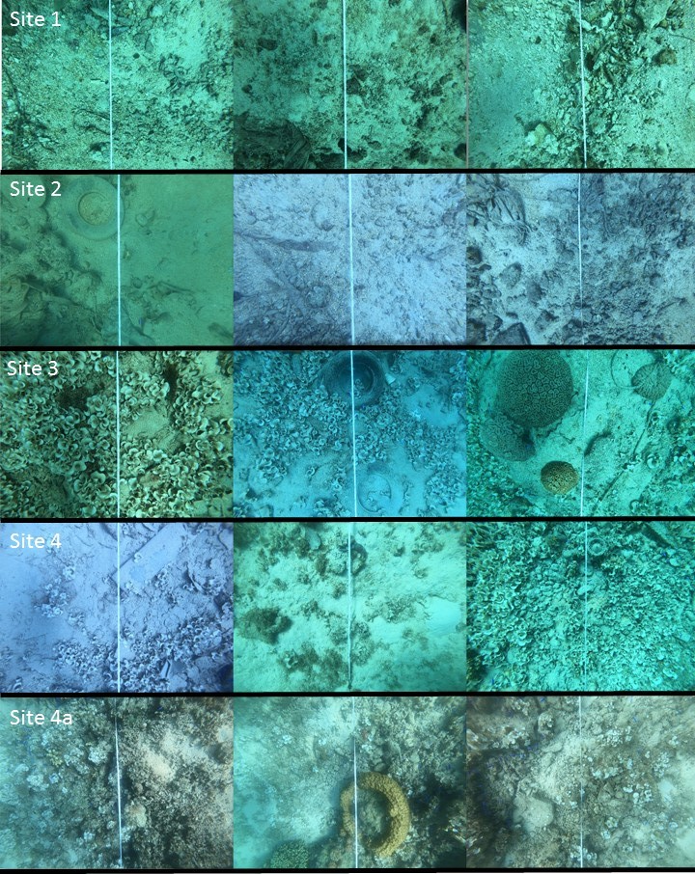

Figure 9 Representative photos of the benthic environment of each surveyed site at Delap Port

## Uliga Port, Majuro

### Uliga Port, Majuro, Benthic Environment Executive Summary

Uliga port is situated on the leeward eastern lagoon shore of the large Island on the eastern corner of Majuro atoll. The benthic habitat around the north and west of the dock is predominately a mix of macroalgae beds on coarse sands with large sandy spaces and sparse visible epiflora or fauna, transitioning via a steep slope to deep lagoon habitat to the west. To the east of the dock, in-between the dock and land, the benthic environment consists of a small reef among coarse sand. To the south of the dock, the habitat transitions from deep lagoon to shallow lagoon abutting fringing reef slope and flat to the island shore. The shallow lagoon here is predominately biotic habitat consisting mostly of macroalgae and algal turf on hard substrate, with some in between coarse sand and sparse individual hard coral colonies. The reef slope to the south-east has relatively high coral cover in a small area (≈35% cover) and abundant algal turf on hard substrate. A quantitative description of the benthic habitats around and immediately adjacent to the port is presented in detail below. The port area appears to already be impacted by industrial activity, given the prevalence of industrial and domestic waste on the seafloor. The proposed project appears to pose little threat to the existing marine benthic environment, however some general recommendations, revolving around pollution management are provided considering the likely industrial operations associated with the project and as a result of potentially increased future port capacity and/or use.

### Uliga Port, Majuro, Benthic Sampling Overview

Uliga Port, Majuro was sampled at two sites on the widest south facing area of the dock (Sites 1 & 2; Fig 10), one site on the eastern side of the main port dock in the shallow inlet between the dock and land (Site 3; Fig 10), one site to the south of the main dock area where habitat transitions from a deep sandy lagoon to a fringing reef slope and reef flat (Sites 4 and 4a; Fig. 10) and one site to the north of the main dock area (Site 5; Fig 10) where habitat transitions from a deep sandy lagoon to a shallow lagoon area before the island shore. In total, the benthic habitat was quantitatively characterized at 2260 randomly selected points from 226 photo-quadrats, representing a random selection of 226 m2 of benthic habitat,from 990 linear meters of haphazardly placed 30m (*n*=33) transects (Table 7).

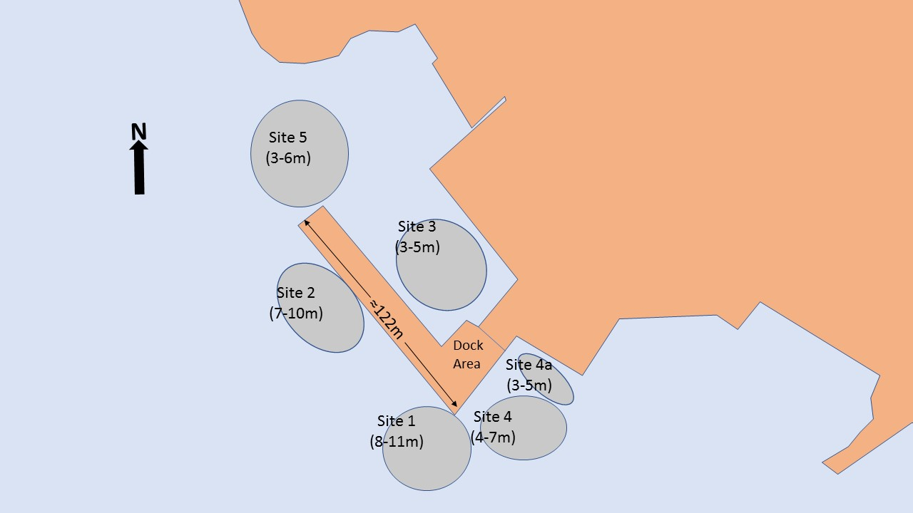

Figure 10 Basic sampling scheme for benthic surveys of Uliga Port. Sampling sites are indicated by named purple circles and approximate depths are given in parentheses. Note, the length of the seaward (western) port bib is shown, but otherwise diagram is not to scale.

Table 7 Sampling effort summary of benthic surveys at Uliga Port. See Figure 10 for schematic of sampling areas in relation to the port

|  |  |  |  |  |  |  |  |
| --- | --- | --- | --- | --- | --- | --- | --- |
| Site | Transect | Total Data Points | Total m2 Sampled | # Quadrats | Mean (M2) Quadrat Size | Min (M2) Quadrat Size | Max (M2) Quadrat Size |
| 1 | 1 | 60 | 6 | 6 | 1 | 1 | 1 |
| 1 | 2 | 70 | 7 | 7 | 1 | 1 | 1 |
| 1 | 3 | 60 | 6 | 6 | 1 | 1 | 1 |
| 1 | 4 | 60 | 6 | 6 | 1 | 1 | 1 |
| 1 | 5 | 60 | 6 | 6 | 1 | 1 | 1 |
| 1 | 6 | 60 | 6 | 6 | 1 | 1 | 1 |
| 1 | 7 | 70 | 7 | 7 | 1 | 1 | 1 |
| 1 | 8 | 60 | 6 | 6 | 1 | 1 | 1 |
| 1 | **Totals** | **500** | **50** | **50** |  |  |  |
| 2 | 1 | 60 | 6 | 6 | 1 | 1 | 1 |
| 2 | 2 | 60 | 6 | 6 | 1 | 1 | 1 |
| 2 | 3 | 60 | 6 | 6 | 1 | 1 | 1 |
| 2 | 4 | 70 | 7 | 7 | 1 | 1 | 1 |
| 2 | 5 | 60 | 6 | 6 | 1 | 1 | 1 |
| 2 | 6 | 60 | 6 | 6 | 1 | 1 | 1 |
| 2 | 7 | 60 | 6 | 6 | 1 | 1 | 1 |
| 2 | 8 | 60 | 6 | 6 | 1 | 1 | 1 |
| 2 | **Totals** | **490** | **49** | **49** |  |  |  |
| 3 | NA – DROP  CAMERA | 240 | 24 | 24 |  |  |  |
| 3 | **Totals** | **240** | **24** | **24** |  |  |  |
| 4 | 1 | 70 | 7 | 7 | 1 | 1 | 1 |
| 4 | 2 | 50 | 5 | 5 | 1 | 1 | 1 |
| 4 | 3 | 60 | 6 | 6 | 1 | 1 | 1 |
| 4 | 4 | 60 | 6 | 6 | 1 | 1 | 1 |
| 4 | 5 | 60 | 6 | 6 | 1 | 1 | 1 |
| 4 | 6 | 60 | 6 | 6 | 1 | 1 | 1 |
| 4 | 7 | 70 | 7 | 7 | 1 | 1 | 1 |
| 4 | 8 | 60 | 6 | 6 | 1 | 1 | 1 |
| 4 | **Totals** | **490** | **49** | **49** |  |  |  |
| 4a | 1 | 70 | 7 | 7 | 1 | 1 | 1 |
| 4a | 2 | 50 | 5 | 5 | 1 | 1 | 1 |
| 4a | **Totals** | **120** | **12** | **12** |  |  |  |
| 5 | 1 | 60 | 6 | 6 | 1 | 1 | 1 |
| 5 | 2 | 60 | 6 | 6 | 1 | 1 | 1 |
| 5 | 3 | 60 | 6 | 6 | 1 | 1 | 1 |
| 5 | 4 | 60 | 6 | 6 | 1 | 1 | 1 |
| 5 | 5 | 60 | 6 | 6 | 1 | 1 | 1 |
| 5 | 6 | 60 | 6 | 6 | 1 | 1 | 1 |
| 5 | 7 | 60 | 6 | 6 | 1 | 1 | 1 |
| 5 | **Totals** | **420** | **42** | **42** |  |  |  |
|  | **Transects** | **Total Data Points** | **Total m2 Sampled** | **# Quadrats** |  |  |  |
| Uliga Totals | 33 | 2260 | 226 | 226 |  |  |  |

### Uliga Port, Majuro, Benthic Environment Description

Excepting the shallow lagoon areas in the harbor and to the north and the fringing reef slop and flat to the south (Sites 3,4 and 5), the benthic habitat at the west-facing main operational area of the port was made up of 30-55% macro-abiotic substrate, ≈20-45% cover of macroalgae and ≈25% cover of algal turf on hard substrates (Sites 1 and 2; Figure 11). The majority of macro-abiotic substrate at these sites consisted of *Halimeda*-derived course sand and bare rubble (Figure 11; Table 8), and the vast majority of identified macroalgae cover was *Padina sp.* meadows, although some *Dictoya sp*. and *Halimeda sp* were also present. At both sites there was also holothuroideans (Sea cucumbers) and some sponges present.

Site 3 was assessed by using a drop camera within the harbor, instead of laying and following individual transects on scuba. Although a slightly different methodology, it also yields 1mx1m quadrats which are then random-point sampled for percent cover of major benthic categories. This site was dominated by biotic cover: predominately algal turf on hard substrate (≈43% cover; Figure 11) but there was also ≈10% cover of both hard corals and macroalgae. Corals present included most branching growth form *Acropora sp.* however some *Porites sp.* were also noted. The macroalgae present that was identified was exclusively *Padina sp.* This site had small areas of exceedingly high hard coral cover (i.e. individual quadrats with >90% hard coral cover) because of a small but thriving reef of different hard coral species.

Site 4 consisted of shallow lagoon area slowly transitioning into fringing reef slope (Site 4a). Site 4 was dominated by macro-abiotic habitat (≈43% cover; Figure 11), mostly coarse sand and bare rubble (Table 8). The biotic substrate present was similar amounts (≈25% cover; Figure 11) of algal turf on hard substrate and macroalgae (mostly *Padina sp*. and *Dictoya sp.*). The sparse hard coral cover here was mostly from solitary corals (Family Fungidae) and some *Pavona* sp.

Site 4a, the steep reef slope transitioning to a reef flat was dominated with biotic cover: mostly hard corals (≈35% cover; Figure 11), algal turf covered hard substrate (≈27% cover; Figure 11) and macroalgae (≈16% cover; Figure 11). Hard corals present were mostly *Acropora spp*. and *Pavona sp.* and macroalgae was predominately *Padina sp.* Most of the macro-abiotic cover was bare rubble (≈15% cover; Table 8), however this site also had a high cover of litter/refuse (Table 8).

Site 5 to the north of the port is a shallow lagoon area dominated by macro-abiotic substrate, almost entirely coarse sand (Figure 11; Table 8). Biotic substrate was mostly both algal turf covered hard substrate and macroalgae (≈25% cover each; Figure 11). Macroalgae present was predominately *Padina sp.* with a few records of *Halimeda sp.* A few sparse colonies of some hard corals were also recorded (*Montipora sp*. and *Porites sp.*).

As with other RMI ports, litter/refuse of both industrial and domestic origin was noted at all locations and was point-scored in quadrats at all sites, with some sites showing ≈10% cover (Sites 2, 3 and 4a: Table 8).

Figure 11 Percent cover of main benthic substrate categories at each surveyed site at Uliga Port. Values are mean values based on stratified random point sampling of individual photo quadrats, summarized by transect, according the sampling summarized in Table 1. Whiskers on bars are Standard Error of the mean

Table 8 Mean coverage of abiotic substrate categories at Uliga Port. Values are mean values (Standard Error) based on stratified random point sampling of individual photo quadrats according the sampling summarized in Table 7.

|  |  |  |  |  |  |  |  |  |  |  |  |  |  |  |  |  |
| --- | --- | --- | --- | --- | --- | --- | --- | --- | --- | --- | --- | --- | --- | --- | --- | --- |
|  | Bare Rock (BARERO) | Bare Rubble (BARERU) | | | Course Sand (CSAND) | Fine Sand (FSAND) | | Litter Industrial (LITI) | | | Litter domestic (LITD) | | NON-CORAL Bolder/Rock (BOLD) | | Silt/MUD (SILT) | |
| Site 1 | 0.00 (0.0) | | 3.43 (1.3) | 22.99  (5.4) | | | 0.00 (0.0) | | 0.57 (0.3) | 2.46 (1.0) | | 0.00 (0.0) | | 0.00 (0.0) | | 0.00 (0.0) | |
| Site 2 | 0.18 (0.2) | | 15.93 (3.0) | 29.21  (7.9) | | | 0.21 (0.2) | | 4.46 (2.2) | 5.47 (1.5) | | 0.00 (0.0) | | 0.00 (0.0) | | 0.18 (0.2) | |
| site 3 | 0.83 (0.6) | | 3.33 (1.4) | 16.25  (5.2) | | | 3.33 (2.4) | | 0.83 (0.6) | 9.17 (4.7) | | 0.00 (0.0) | | 0.00 (0.0) | | 0.83 (0.6) | |
| site 4 | 0.00 (0.0) | | 11.62 (3.6) | 23.84  (6.4) | | | 0.00 (0.0) | | 0.58 (0.4) | 6.78 (3.7) | | 0.00 (0.0) | | 0.00 (0.0) | | 0.00 (0.0) | |
| Site 4a | 0.00 (0.0) | | 15.00 (0.0) | 0.00  (0.0) | | | 0.00 (0.0) | | 4.17 (4.2) | 7.50 (0.8) | | 0.00 (0.0) | | 0.00 (0.0) | | 0.00 (0.0) | |
| site 5 | 0.00 (0.0) | | 1.68 (0.7) | 48.59  (5.2) | | | 0.48 (0.5) | | 0.00 (0.0) | 0.24 (0.2) | | 0.00 (0.0) | | 0.00 (0.0) | | 0.00 (0.0) | |

Representative images of all sites at Uliga are shown in Figure 12.

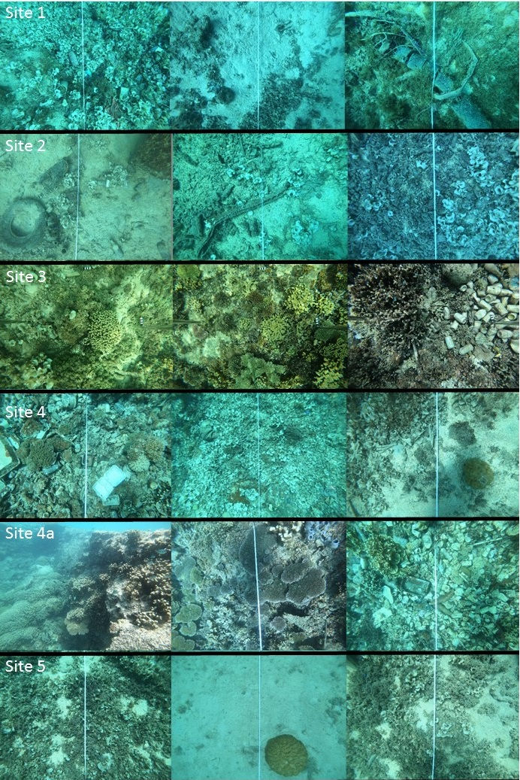

Figure 12Some representative photos of the benthic environment of each surveyed site at Uliga Port.

# Part Three: Project Marine Environmental Risks

Despite reef flat environments near some ports, the diversity of marine benthic habitats and organisms immediately surrounding, and adjacent to the ports is generally low, except for the reef slope environments noted above. Most benthic substrate in the main operational areas of ports is dominated by soft sediments, hard substrates with algal turf and thus much of the associated fauna is likely infauna (*i.e.* fauna that lives exclusively within the sediments). Given that the proposed physical investments do not involve extending the port footprint or in-water construction activity, such as dredging, piling etc, and considering that the nature of the work activities for the physical investments are similar to present ongoing industrial activities at the port, it is considered that the risks of the project to the existing benthic environment at all ports are minimal. There are, however, generic risks to the marine environment from increasing and ongoing industrial activity at the port the project should consider:

* **Light pollution:** Marine fauna can be adversely affected by artificial light - These effects may include adverse effects to marine zooplankton behavior, adverse effects from fish aggregations at artificial light sources, potential effects on invertebrate spawning behavior where lunar phase is used as a cue and displacement and/or disorientation of some marine wildlife (particularly marine turtles (hatchlings and adults) and marine birds) (Davies *et al.* 2014). Despite this, the impacts from the new lighting in the proposed project are expected to be negligible, particularly given the extensive existing artificial lighting already in the area, and the fact that there doesn’t appear to be any sea turtle nesting habitat or significant seabird nesting areas in the coastal vicinity of the port.
* **Diffuse ship- and land-based pollution:** There was a considerable amount of industrial (i.e. likely refuse from port/shipping activities, for example, tires, steel wire etc) and domestic (i.e. personal/small scale waste, for example cans, plastic bags etc) hard waste seen during dives around the port and noted in photo quadrats. This indicates that it is highly likely more rigorous waste management practices are required. The management of wastes generated as a result industrial activity at the port needs to be an explicit part of any environmental plan of the port, as does monitoring of their efficacy. Given there will be increased industrial activity as a result of the works of this project, and possibly ongoing afterward due to a potential increase in port capacity and/or use, it is recommended a port environmental management plan addressing this be implemented as part of this project and/or any future port master plan.

Another area which should be considered in terms of this project and any current/future environmental management plan is the control of drainage away from the port in consideration of both hard waste and importantly, processes and procedures for the prevention and management of petrochemical spills. During tours of the port sites it was noted that hydrocarbon distribution (i.e. refueling sites etc) was not confined to a contained, bunded areas and there were no spill-kits available in the event of accidental petrochemical spills. Again, given there will be increased industrial activity as a result of the works of this project, and possibly ongoing afterward due to a potential increase in port capacity and/or use, it is recommended a port environmental management plan addressing this be implemented as part of this project and/or any future port master plan

# Appendix 1 – Benthic Habitat/Taxonomic Group Categories Used to Describe Benthic Environments

|  |
| --- |
| MAJOR CATEGORY (% of transect) |
| CORAL (C) |
| OTHER INVERT (OI) |
| ABIOTIC (A) |
| SEAGRASS (SG) |
| CROPPED/OTHER ALGAE (CA) |
| MACROALGAE (MA) |
| UNIDENTIFIED (U) |
| TAPE, WAND, SHADOW (TWS) |
| Sum (excluding tape+shadow+wand) |
|  |
| SUBCATEGORIES (% of transect) |
| CORAL (C) |
| Branching Coral (BC) |
| Columnar Coral (CC) |
| Dead Coral (DEAD) |
| Digitate coral (DC) |
| Encusting Coral (EC) |
| Foliose/Laminar Coral (FLC) |
| Massive Coral (MC) |
| Solitary Coral (SC) |
| Tabular Coral (TC) |
| Unindentified coral (UNCO) |
| OTHER INVERT (OI) |
| Anenome (ANEM) |
| Asteroidea (ASTE) |
| Bryozoan (BRYO) |
| Holothuriodian (HOLO) |
| Mobile Invert (MINV) |
| Octocoral (OCTO) |
| Octocoral on dead coral (OC/DL) |
| Octocoral on rubble (OC/R) |
| Other sessile inverts (OSIN) |
| Sponge (SPNG) |
| Tunicate (TUNI) |
| Zoanthid (ZOAN) |
| ABIOTIC (A) |
| Bare Rock (BARERO) |
| Bare Rubble (BARERU) |
| Bedrock (BED) |
| Black Hole (BHOL) |
| Coral Rubble Silt Covered (CRUSI) |
| Course Sand (CSAND) |
| Fine Sand (FSAND) |
| Litter Industrial (LITI) |
| Litter domestic (LITD) |
| NON-CORAL Bolder/Rock (BOLD) |
| Silt/MUD (SILT) |
| SEAGRASS (SG) |
| Cymodocea sp (SGCY) |
| Halophila sp (SGHA) |
| Syringodium sp. (SGSY) |
| Thalassia sp. (SGTH) |
| UNID Seagrass (SEAG) |
| CROPPED/OTHER ALGAE (CA) |
| Blue greed on dead compressa (BG/DC) |
| Blue green (BLGR) |
| Blue green on dead coral (BG/DL) |
| Blue green on rubble (BG/R) |
| Crustose (CRST) |
| Crustose on dead compressa (CR/DC) |
| Crustose on dead coral (CR/DL) |
| Crustose on rubble (CR/R) |
| Turf/Bare (TU/B) |
| Turf/Bare on dead compress (TB/DC) |
| Turf/Bare on dead coral (TB/DL) |
| Turf/Bare on rubble (TB/R) |
| MACROALGAE (MA) |
| Acanthophora spicifera (ASPI) |
| Asparagopsis sp (ASPA) |
| Avrainvillea sp (AVRA) |
| Caulerpa sp. (CAUL) |
| Cladophora sp (CLAD) |
| Codium sp (CODI) |
| Crustose Macroalgae (CMAC) |
| Dictyosphaeria cavernosa (DCAV) |
| Dictyosphaeria versluysii (DVER) |
| Dictyota sp (DICT) |
| Galaxaura sp. (GALA) |
| Gelatinous red (GOOEY) |
| Gracillaria salicornia (GSAL) |
| Halimeda sp. (HALI) |
| Halymenia sp (HALY) |
| Hypnea musciformis (HMUS) |
| Jointed calcareous red (JCAL) |
| Kappaphycus sp (KAPP) |
| Large macroalgae (MACR) |
| Liagora sp (LIAG) |
| Lobophora sp (LOBO) |
| Low macroalgae (LMAC) |
| Neomeris sp (NEOM) |
| Padina sp (PADI) |
| Sargassum sp (SARG) |
| Stypopodium sp (STYP) |
| Turbinaria sp (TURB) |
| Unindentifed brown (UBRN) |
| Unindentified green (UGRE) |
| Unindentified red (URED) |
| Ventricaria sp (VENT) |
| UNIDENTIFIED (U) |
| Unidentified (UNID) |
| TAPE, WAND, SHADOW (TWS) |
| Shadow (SHADOW) |
| Tape (TAPE) |
| Wand (WAND) |
|  |
| NOTES (% of transect) |
| Acanthastrea (ACAN) |
| Acropora (ACRO) |
| Africana (AFRI) |
| Agaricia (AGAR) |
| Alatotrochus (ALAT) |
| Alveopora (ALVE) |
| Amphihelia (AMPH) |
| Anacropora (ANAC) |
| Anomastraea (ANOMA) |
| Anomocora (ANOM) |
| Anthemiphyllia (ANTH) |
| Antillia (ANTI) |
| Astrangia (ASTRA) |
| Astrea (ASTR) |
| Astreopora (ASTRE) |
| Astroides (ASTRO) |
| Aulocyathus (AULO) |
| Australocyathus (AUSTC) |
| Australogyra (AUSTG) |
| Australophyllia (AUSTP) |
| Bachytrochus (BACH) |
| Balanophyllia (BALAPH) |
| Balanopsammia (BALAPS) |
| Bathelia (BATH) |
| Bathycyathus (BATHC) |
| Bathypsammia (BATHP) |
| Bernardpora (BERN) |
| Blastomussa (BLASM) |
| Blastotrochus (BLAST) |
| Boninastrea (BONI) |
| Bourneotrochus (BOUR) |
| Cantharellus (CANT) |
| Caryophyllia (CARY) |
| Catalaphyllia (CATA) |
| Caulastraea (CAUL) |
| Ceratotrochus (CERA) |
| Cladangia (CLADA) |
| Cladocora (CLADO) |
| Cladopsammia (CLADS) |
| Coelastrea (COELTR) |
| Coeloseris (COEL) |
| Coenocyathus (COENC) |
| Coenosmilia (COENS) |
| Colangia (COLA) |
| Colpophyllia (COLP) |
| Concentrotheca (CONC) |
| Confluphyllia (CONF) |
| Conocyathus (CONO) |
| Conotrochus (CONOT) |
| Coscinaraea (COSC) |
| Craterastrea (CRAT) |
| Crispatotrochus (CRIS) |
| Cryptotrochus (CRYP) |
| Ctenactis (CTEN) |
| Ctenella (CTENE) |
| Culicia (CULI) |
| Cyathelia (CYATE) |
| Cyathotrochus (CYAT) |
| Cycloseris (CYCL) |
| Cynarina (CYNA) |
| Cyphastrea (CYPH) |
| Dactylotrochus (DACT) |
| Danafungia (DANA) |
| Dasmosmilia (DASM) |
| Deltocyathoides (DELT) |
| Deltocyathus (DELTU) |
| Dendrocora (DENDC) |
| Dendrogyra (DENDA) |
| Dendrophyllia (DEND) |
| Desmophyllum (DESM) |
| Dichocoenia (DICH) |
| Dichopsammia (DICHP) |
| Diploastrea (DIPLA) |
| Diploria (DIPL) |
| Dipsastraea (DIPS) |
| Duncanopsammia (DUNC) |
| Dunocyathus (DUNO) |
| Echinomorpha (ECHIM) |
| Echinophyllia (ECHIP) |
| Echinopora (ECHI) |
| Eguchipsammia (EGUC) |
| Enallopsammia (ENAL) |
| Endocyathopora (ENDO) |
| Endopachys (ENDOC) |
| Endopsammia (ENDOP) |
| Enigmopora (ENIG) |
| Ericiocyathus (ERIC) |
| Erythrastrea (ERYT) |
| Euphyllia (EUPH) |
| Eusmilia (EUSM) |
| Falcatoflabellum (FALC) |
| Family Acroporidae (FAM-ACROP) |
| Family Agariciidae (FAM-AGARI) |
| Family Anthemiphylliidae (FAM-ANTHE) |
| Family Astrocoeniidae (FAM-ASTRO) |
| Family Caryophylliidae (FAM-CARYO) |
| Family Coscinaraeidae (FAM-COSCI) |
| Family Deltocyathidae (FAM-DELTO) |
| Family Dendrophylliidae (FAM-DENDR) |
| Family Diploastreidae (FAM-DIPLO) |
| Family Euphylliidae (FAM-EUPHY) |
| Family Faviidae (FAM-FAVII) |
| Family Flabellidae (FAM-FLABE) |
| Family Fungiacyathidae (FAM-FUNGIC) |
| Family Fungiidae (FAM-FUNGI) |
| Family Gardineriidae (FAM-GARDI) |
| Family Guyniidae (FAM-GUYNI) |
| Family Lobophylliidae (FAM-LOBOP) |
| Family Meandrinidae (FAM-MEAND) |
| Family Merulinidae (FAM-MERUL) |
| Family Micrabaciidae (FAM-MICRA) |
| Family Not (FAM-UNID) |
| Family Oculinidae (FAM-OCULI) |
| Family Plesiastreidae (FAM-PLESI) |
| Family Pocilloporidae (FAM-POCIL) |
| Family Poritidae (FAM-PORIT) |
| Family Psammocoridae (FAM-PSAMM) |
| Family Rhizangiidae (FAM-RHIZA) |
| Family Schizocyathidae (FAM-SCHIZ) |
| Family Siderastreidae (FAM-SIDER) |
| Family Stenocyathidae (FAM-STENO) |
| Family Turbinoliidae (FAM-TURBI) |
| Favia (FAVIA) |
| Favites (FAVIT) |
| Fimbriaphyllia (FIMB) |
| Flabellum (FLAB) |
| Foveolocyathus (FOVE) |
| Fungia (FUNG) |
| Fungiacyathus (FUNGC) |
| Galaxea (GALA) |
| Gardineria (GARDA) |
| Gardineroseris (GARDS) |
| Goniastrea (GONI) |
| Goniocorella (GONIC) |
| Goniopora (GONIP) |
| Guynia (GUYN) |
| Gyrosmilia (GYRO) |
| Halomitra (HALO) |
| Heliofungia (HELIF) |
| Helioseris (HELI) |
| Herpolitha (HERP) |
| Heterocyathus (HETEC) |
| Heteropsammia (HETEP) |
| Holcotrochus (HOLC) |
| Homophyllia (HOMO) |
| Hoplangia (HOPL) |
| Horastrea (HORA) |
| Hydnophora (HYDN) |
| Idiotrochus (IDIO) |
| Isophyllia (ISOPH) |
| Isopora (ISOPO) |
| Javania (JAVA) |
| Kionotrochus (KION) |
| Labyrinthocyathus (LABY) |
| Leptastrea (LEPT) |
| Leptopenus (LEPTP) |
| Leptopsammia (LEPTM) |
| Leptoria (LEPTA) |
| Leptoseris (LEPTS) |
| Letepsammia (LETE) |
| Lissotrochus (LISS) |
| Lithophyllon (LITH) |
| Lobactis (LOBA) |
| Lobophyllia (LOBO) |
| Lochmaeotrochus (LOCH) |
| Machadoporites (MACH) |
| Madracis (MADRA) |
| Madrepora (MADR) |
| Manicina (MANI) |
| Meandrina (MEAN) |
| Merulina (MERU) |
| Micromussa (MICR) |
| Monohedotrochus (MONOH) |
| Monomyces (MONO) |
| Montigyra (MONT) |
| Montipora (MONTI) |
| Moseleya (MOSE) |
| Mussa (MUSSA) |
| Mussismilia (MUSS) |
| Mycedium (MYCE) |
| Mycetophyllia (MYCET) |
| Nemenzophyllia (NEME) |
| Nomlandia (NOML) |
| Notocyathus (NOTO) |
| Notophyllia (NOTOP) |
| Oculina (OCUL) |
| Orbicella (ORBI) |
| Oulangia (OULAN) |
| Oulastrea (OULA) |
| Oulophyllia (OULO) |
| Oxypora (OXYP) |
| Oxysmilia (OXYS) |
| Pachyseris (PACH) |
| Palauastrea (PALA) |
| Paraconotrochus (PARAC) |
| Paracyathus (PARACY) |
| Paragoniastrea (PARAG) |
| Paramontastraea (PARA) |
| Pavona (PAVO) |
| Pectinia (PECT) |
| Pedicellocyathus (PEDI) |
| Peponocyathus (PEPO) |
| Petrophyllia (PETR) |
| Phacelocyathus (PHAC) |
| Phyllangia (PHYL) |
| Physogyra (PHYS) |
| Physophyllia (PHYSP) |
| Placotrochides (PLACC) |
| Placotrochus (PLAC) |
| Platygyra (PLATG) |
| Platytrochus (PLAT) |
| Pleotrochus (PLEO) |
| Plerogyra (PLER) |
| Plesiastrea (PLES) |
| Pleuractis (PLEU) |
| Pocillopora (POCI) |
| Podabacia (PODA) |
| Polycyathus (POLYC) |
| Polymyces (POLYM) |
| Polyphyllia (POLY) |
| Porites (PORI) |
| Pourtalocyathus (POUR) |
| Pourtalopsammia (POURP) |
| Pourtalosmilia (POURS) |
| Premocyathus (PREM) |
| Psammocora (PSAM) |
| Pseudocyathoceras (PSEUC) |
| Pseudodiploria (PSEUD) |
| Pseudosiderastrea (PSEUS) |
| Rhizopsammia (RHIZP) |
| Rhizosmilia (RHIZS) |
| Rhizotrochus (RHIZ) |
| Rhombopsammia (RHOM) |
| Sandalolitha (SAND) |
| Scapophyllia (SCAP) |
| Schizoculina (SCHIL) |
| Schizocyathus (SCHI) |
| Sclerhelia (SCLE) |
| Sclerophyllia (SCLEP) |
| Scolymia (SCOL) |
| Seriatopora (SERI) |
| Siderastrea (SIDE) |
| Simplastrea (SIMP) |
| Sinuorota (SINU) |
| Solenastrea (SOLE) |
| Solenosmilia (SOLEO) |
| Sphenotrochus (SPHE) |
| Stenocyathus (STEN) |
| Stephanocoenia (STEPC) |
| Stephanocyathus (STEPY) |
| Stephanophyllia (STEP) |
| Stolarskicyathus (STOL) |
| Stylaraea (STYL) |
| Stylocoeniella (STYLC) |
| Stylophora (STYLP) |
| Sympodangia (SYMP) |
| Temnotrochus (TEMN) |
| Tethocyathus (TETH) |
| Thalamophyllia (THAL) |
| Thecopsammia (THEC) |
| Thrypticotrochus (THRY) |
| Trachyphyllia (TRAC) |
| Trematotrochus (TREM) |
| Trochocyathus (TROCC) |
| Trochopsammia (TROC) |
| Tropidocyathus (TROP) |
| Truncatoflabellum (TRUNF) |
| Truncatoguynia (TRUN) |
| Tubastraea (TUBA) |
| Turbinaria (TURB) |
| Turbinolia (TURBO) |
| Vaughanella (VAUG) |
| Zoopilus (ZOOP) |
| NOTES (% of coral) |
| Acanthastrea (ACAN) |
| Acropora (ACRO) |
| Africana (AFRI) |
| Agaricia (AGAR) |
| Alatotrochus (ALAT) |
| Alveopora (ALVE) |
| Amphihelia (AMPH) |
| Anacropora (ANAC) |
| Anomastraea (ANOMA) |
| Anomocora (ANOM) |
| Anthemiphyllia (ANTH) |
| Antillia (ANTI) |
| Astrangia (ASTRA) |
| Astrea (ASTR) |
| Astreopora (ASTRE) |
| Astroides (ASTRO) |
| Aulocyathus (AULO) |
| Australocyathus (AUSTC) |
| Australogyra (AUSTG) |
| Australophyllia (AUSTP) |
| Bachytrochus (BACH) |
| Balanophyllia (BALAPH) |
| Balanopsammia (BALAPS) |
| Bathelia (BATH) |
| Bathycyathus (BATHC) |
| Bathypsammia (BATHP) |
| Bernardpora (BERN) |
| Blastomussa (BLASM) |
| Blastotrochus (BLAST) |
| Boninastrea (BONI) |
| Bourneotrochus (BOUR) |
| Cantharellus (CANT) |
| Caryophyllia (CARY) |
| Catalaphyllia (CATA) |
| Caulastraea (CAUL) |
| Ceratotrochus (CERA) |
| Cladangia (CLADA) |
| Cladocora (CLADO) |
| Cladopsammia (CLADS) |
| Coelastrea (COELTR) |
| Coeloseris (COEL) |
| Coenocyathus (COENC) |
| Coenosmilia (COENS) |
| Colangia (COLA) |
| Colpophyllia (COLP) |
| Concentrotheca (CONC) |
| Confluphyllia (CONF) |
| Conocyathus (CONO) |
| Conotrochus (CONOT) |
| Coscinaraea (COSC) |
| Craterastrea (CRAT) |
| Crispatotrochus (CRIS) |
| Cryptotrochus (CRYP) |
| Ctenactis (CTEN) |
| Ctenella (CTENE) |
| Culicia (CULI) |
| Cyathelia (CYATE) |
| Cyathotrochus (CYAT) |
| Cycloseris (CYCL) |
| Cynarina (CYNA) |
| Cyphastrea (CYPH) |
| Dactylotrochus (DACT) |
| Danafungia (DANA) |
| Dasmosmilia (DASM) |
| Deltocyathoides (DELT) |
| Deltocyathus (DELTU) |
| Dendrocora (DENDC) |
| Dendrogyra (DENDA) |
| Dendrophyllia (DEND) |
| Desmophyllum (DESM) |
| Dichocoenia (DICH) |
| Dichopsammia (DICHP) |
| Diploastrea (DIPLA) |
| Diploria (DIPL) |
| Dipsastraea (DIPS) |
| Duncanopsammia (DUNC) |
| Dunocyathus (DUNO) |
| Echinomorpha (ECHIM) |
| Echinophyllia (ECHIP) |
| Echinopora (ECHI) |
| Eguchipsammia (EGUC) |
| Enallopsammia (ENAL) |
| Endocyathopora (ENDO) |
| Endopachys (ENDOC) |
| Endopsammia (ENDOP) |
| Enigmopora (ENIG) |
| Ericiocyathus (ERIC) |
| Erythrastrea (ERYT) |
| Euphyllia (EUPH) |
| Eusmilia (EUSM) |
| Falcatoflabellum (FALC) |
| Family Acroporidae (FAM-ACROP) |
| Family Agariciidae (FAM-AGARI) |
| Family Anthemiphylliidae (FAM-ANTHE) |
| Family Astrocoeniidae (FAM-ASTRO) |
| Family Caryophylliidae (FAM-CARYO) |
| Family Coscinaraeidae (FAM-COSCI) |
| Family Deltocyathidae (FAM-DELTO) |
| Family Dendrophylliidae (FAM-DENDR) |
| Family Diploastreidae (FAM-DIPLO) |
| Family Euphylliidae (FAM-EUPHY) |
| Family Faviidae (FAM-FAVII) |
| Family Flabellidae (FAM-FLABE) |
| Family Fungiacyathidae (FAM-FUNGIC) |
| Family Fungiidae (FAM-FUNGI) |
| Family Gardineriidae (FAM-GARDI) |
| Family Guyniidae (FAM-GUYNI) |
| Family Lobophylliidae (FAM-LOBOP) |
| Family Meandrinidae (FAM-MEAND) |
| Family Merulinidae (FAM-MERUL) |
| Family Micrabaciidae (FAM-MICRA) |
| Family Not (FAM-UNID) |
| Family Oculinidae (FAM-OCULI) |
| Family Plesiastreidae (FAM-PLESI) |
| Family Pocilloporidae (FAM-POCIL) |
| Family Poritidae (FAM-PORIT) |
| Family Psammocoridae (FAM-PSAMM) |
| Family Rhizangiidae (FAM-RHIZA) |
| Family Schizocyathidae (FAM-SCHIZ) |
| Family Siderastreidae (FAM-SIDER) |
| Family Stenocyathidae (FAM-STENO) |
| Family Turbinoliidae (FAM-TURBI) |
| Favia (FAVIA) |
| Favites (FAVIT) |
| Fimbriaphyllia (FIMB) |
| Flabellum (FLAB) |
| Foveolocyathus (FOVE) |
| Fungia (FUNG) |
| Fungiacyathus (FUNGC) |
| Galaxea (GALA) |
| Gardineria (GARDA) |
| Gardineroseris (GARDS) |
| Goniastrea (GONI) |
| Goniocorella (GONIC) |
| Goniopora (GONIP) |
| Guynia (GUYN) |
| Gyrosmilia (GYRO) |
| Halomitra (HALO) |
| Heliofungia (HELIF) |
| Helioseris (HELI) |
| Herpolitha (HERP) |
| Heterocyathus (HETEC) |
| Heteropsammia (HETEP) |
| Holcotrochus (HOLC) |
| Homophyllia (HOMO) |
| Hoplangia (HOPL) |
| Horastrea (HORA) |
| Hydnophora (HYDN) |
| Idiotrochus (IDIO) |
| Isophyllia (ISOPH) |
| Isopora (ISOPO) |
| Javania (JAVA) |
| Kionotrochus (KION) |
| Labyrinthocyathus (LABY) |
| Leptastrea (LEPT) |
| Leptopenus (LEPTP) |
| Leptopsammia (LEPTM) |
| Leptoria (LEPTA) |
| Leptoseris (LEPTS) |
| Letepsammia (LETE) |
| Lissotrochus (LISS) |
| Lithophyllon (LITH) |
| Lobactis (LOBA) |
| Lobophyllia (LOBO) |
| Lochmaeotrochus (LOCH) |
| Machadoporites (MACH) |
| Madracis (MADRA) |
| Madrepora (MADR) |
| Manicina (MANI) |
| Meandrina (MEAN) |
| Merulina (MERU) |
| Micromussa (MICR) |
| Monohedotrochus (MONOH) |
| Monomyces (MONO) |
| Montigyra (MONT) |
| Montipora (MONTI) |
| Moseleya (MOSE) |
| Mussa (MUSSA) |
| Mussismilia (MUSS) |
| Mycedium (MYCE) |
| Mycetophyllia (MYCET) |
| Nemenzophyllia (NEME) |
| Nomlandia (NOML) |
| Notocyathus (NOTO) |
| Notophyllia (NOTOP) |
| Oculina (OCUL) |
| Orbicella (ORBI) |
| Oulangia (OULAN) |
| Oulastrea (OULA) |
| Oulophyllia (OULO) |
| Oxypora (OXYP) |
| Oxysmilia (OXYS) |
| Pachyseris (PACH) |
| Palauastrea (PALA) |
| Paraconotrochus (PARAC) |
| Paracyathus (PARACY) |
| Paragoniastrea (PARAG) |
| Paramontastraea (PARA) |
| Pavona (PAVO) |
| Pectinia (PECT) |
| Pedicellocyathus (PEDI) |
| Peponocyathus (PEPO) |
| Petrophyllia (PETR) |
| Phacelocyathus (PHAC) |
| Phyllangia (PHYL) |
| Physogyra (PHYS) |
| Physophyllia (PHYSP) |
| Placotrochides (PLACC) |
| Placotrochus (PLAC) |
| Platygyra (PLATG) |
| Platytrochus (PLAT) |
| Pleotrochus (PLEO) |
| Plerogyra (PLER) |
| Plesiastrea (PLES) |
| Pleuractis (PLEU) |
| Pocillopora (POCI) |
| Podabacia (PODA) |
| Polycyathus (POLYC) |
| Polymyces (POLYM) |
| Polyphyllia (POLY) |
| Porites (PORI) |
| Pourtalocyathus (POUR) |
| Pourtalopsammia (POURP) |
| Pourtalosmilia (POURS) |
| Premocyathus (PREM) |
| Psammocora (PSAM) |
| Pseudocyathoceras (PSEUC) |
| Pseudodiploria (PSEUD) |
| Pseudosiderastrea (PSEUS) |
| Rhizopsammia (RHIZP) |
| Rhizosmilia (RHIZS) |
| Rhizotrochus (RHIZ) |
| Rhombopsammia (RHOM) |
| Sandalolitha (SAND) |
| Scapophyllia (SCAP) |
| Schizoculina (SCHIL) |
| Schizocyathus (SCHI) |
| Sclerhelia (SCLE) |
| Sclerophyllia (SCLEP) |
| Scolymia (SCOL) |
| Seriatopora (SERI) |
| Siderastrea (SIDE) |
| Simplastrea (SIMP) |
| Sinuorota (SINU) |
| Solenastrea (SOLE) |
| Solenosmilia (SOLEO) |
| Sphenotrochus (SPHE) |
| Stenocyathus (STEN) |
| Stephanocoenia (STEPC) |
| Stephanocyathus (STEPY) |
| Stephanophyllia (STEP) |
| Stolarskicyathus (STOL) |
| Stylaraea (STYL) |
| Stylocoeniella (STYLC) |
| Stylophora (STYLP) |
| Sympodangia (SYMP) |
| Temnotrochus (TEMN) |
| Tethocyathus (TETH) |
| Thalamophyllia (THAL) |
| Thecopsammia (THEC) |
| Thrypticotrochus (THRY) |
| Trachyphyllia (TRAC) |
| Trematotrochus (TREM) |
| Trochocyathus (TROCC) |
| Trochopsammia (TROC) |
| Tropidocyathus (TROP) |
| Truncatoflabellum (TRUNF) |
| Truncatoguynia (TRUN) |
| Tubastraea (TUBA) |
| Turbinaria (TURB) |
| Turbinolia (TURBO) |
| Vaughanella (VAUG) |
| Zoopilus (ZOOP) |